**HANOI UNIVERSITY OF SCIENCE AND TECHNOLOGY**

**GRADUATION PROJECT**

**Designing a self-driving car model using image processing technology**

**VO TRAN TRUNG HIEU**

Hieu.vtt186104@sis.hust.edu.vn

**Automotive Engineering**

|  |  |
| --- | --- |
| **Instructor:** | Prof. Phạm Minh Tuấn  Signature of instructor |
| **Department:** | Internal Combustion Engine |
| **School:** | Transportation Engineering |
| **HA NOI, 7/2022** | |

**Graduation Project Topic**

1. **Project Name**

***Designing a self-driving car model using image processing technology***

1. **Initial Documentation**

- Theoretical documents of image processing technology

- Documents on the Internet about self-driving cars

- Documents and data obtained during internship at FPT Software

1. **Contents of explanations and calculations**

**Acknowledgement**

Summary of project content (Start with the reason for choosing the topic or the origin of the topic)

**Chapter I. Autonomous Vehicle Overview**

1.1 Autonomous vehicle history

1.2 Methods of controlling autonomous vehicles (or classification of autonomous vehicles)

1.3 Research, production and development trends of autonomous vehicles in the world

1.4 Situation of self-driving cars in Vietnam

1.5 ntroduce the direction of the project and specific contents

**Chapter II. Design a self-driving car model**

2.1 Select design objects (how big is the model, how is the structure, how to control ...)

2.2 Hardware Design

2.3 Software Design

**Chapter III. Build and test a self-driving car model**

3.1 Purpose and test procedure

3.2 Test results and discussion

**Conclusions and suggestions**

**References**

**Attention:** Format for project description in accordance with the requirements of HUST

<https://ctt.hust.edu.vn/DisplayWeb/DisplayBaiViet?baiviet=35523>)

1. **Number and name of drawings** (size A0)

- Drawings showing the main contents of Chapter I

- Drawings showing the contents of Chapter II

- Drawings showing the contents of Chapter III

1. **Project start date**: March 28, 2022
2. **Project end date**: July 15, 2022

*Hanoi, March 28, 2022*

**Head of specialized group**  **Supervisor**

**Prof. Pham Minh Tuan**

**Acknowledgements**

During my reseach of this project, I have received a lot of valuable guidance from teachers and colleagues. With deep gratitude, I would like to express my thanks to:

* Professor Phạm Minh Tuấn for his helps and encouragement so that I have successfully completed my graduation project.
* FPT Software’s colleagues who provides me with a lot of helpful information and useful practical knowledge to make my graduation project better.

**Project summary**

In the project, this self-driving car model has the ability to recognize the way through the camera mounted on the vehicle. It can steer in directions that correspond to the path it perceives. To do that, the model is installed with a Raspberry Pi Four processor, it receives data that is an image taken from the camera on the model and then makes a decision corresponding to the received data. The microprocessor will then send a request to the motor control module – the component that directly controls four electric motors installed at four wheels. It can be said that this autonomous vehicle model is equivalent to a level three autonomous vehicle model. It has high practicality and low cost because it does not use additional sensors. It is capable of operating well in a controlled environment (an environment where the path and the objects on the path are known by the model). In the future, in order for the model to be able to operate in an uncontrolled environment, it needs to be equipped with additional hardware and software such as: LiDAR, ultrasonic sensors, maps, the ability to communicate with other devices, other vehicles. Through the process of doing the project, I learned a lot more knowledge about electronic control, how to design models, especially programming: microcontroller programming, image processing programming.

Project owner

**TABLE OF CONTENTS**

CHAPTER 1. INTRODUCTION 1

1.1 Introduction to Computer Vision 1

1.1.1 Computer vision definition 1

1.1.2 The importance of computer vision 1

1.1.3 History and milestones computer vision 1

1.1.4 Applications of computer vision 1

1.1.5 Common computer vision tasks 2

1.1.6 Computer vision tools 4

1.2 Introduction to Self-Driving Car and Six Levels of Autonomous Driving 5

1.3 Computer Vision and Autonomous Driving 6

1.4 Objectives and Limitation of the Graduation Project 7

CHAPTER 2. COMPUTER VISION THEORY AND APPLICATIONS 8

2.1 Computer Vision Theory 8

2.1.1 Computer vision pipeline 8

2.1.2 Formation of digital image 10

2.1.3 Images as numerical data 10

2.1.4 Color spaces 11

2.1.5 Filters 14

2.1.6 Frequency in images 17

2.1.7 Gaussian blur 18

2.1.8 Dilation and erosion 19

2.2 Applying Computer Vision to Build Lane Detecting Algorithm 20

2.2.1 Pipeline 20

2.2.2 Grey scale conversion and image resizing 21

2.2.3 Gamma correction 21

2.2.4 Image thresholding 25

2.2.5 Image warping 28

2.2.6 Finding curve 29

2.2.7 Optimizing curve 31

2.2.8 Motor controlling 32

CHAPTER 3. DESIGNING THE AUTONOMOUS CAR MODEL 34

3.1 Model Physical Design 34

3.1.1 Model assembly 34

3.1.2 Chassis 35

3.1.3 Camera case 36

3.2 Model Electrical Design 38

3.2.1 Model schematic 38

3.2.2 Raspberry Pi 4 Model B 38

3.2.3 Electric motor 42

3.2.4 Motor controller 43

3.2.5 Battery 46

3.2.6 LM2596 voltage regulator 46

3.2.7 Camera and camera case 47

3.3 Running the Autonomous Car 47

3.3.1 The problems when running the car model 47

3.3.2 Solutions 48

CHAPTER 4. CONCLUSION 49

4.1 Conclusion 49

4.2 Future Work 49

REFERENCES 50

**LIST OF FIGURES**

Figure 1.1. Image classification of dogs and cats 3

Figure 1.2. Detecting relationships in an image 3

Figure 1.3. Face recognition algorithm 4

Figure 1.4. Color-coding objects with the same class 4

Figure 1.5. Six levels of autonomous driving defined by SAE 5

Figure 2.1. Computer vision pipeline 8

Figure 2.2. Simple classification algorithm 8

Figure 2.3. Image preprocessing 9

Figure 2.4. How the camera captures an image 10

Figure 2.5. Images are constructed by many small picture elements 11

Figure 2.6. Color images are stacks of three different 2-dimension color layers 11

Figure 2.7. RGB color space 12

Figure 2.8. How an image in RBG represented in three layers of color intensity 13

Figure 2.9. HSV and HSL color space 13

Figure 2.10. Image after applying filter 14

Figure 2.11. Edge detection filter 14

Figure 2.12. Applying filter to images mathematically 15

Figure 2.13. Regions with little change in intensity 16

Figure 2.14. Regions with intense changed in frequency 16

Figure 2.15. Noise in an image 16

Figure 2.16. Averaging filter 17

Figure 2.17. Noise in image is smoothed by low-pass filter 17

Figure 2.18. High and low frequency 18

Figure 2.19. Blue area: low frequency. Pink area: high frequency 18

Figure 2.20. Erosion and Dilation 20

Figure 2.21. Opening 20

Figure 2.22. Closing 20

Figure 2.23. Flowchart of the lane detecting algorithm 22

Figure 2.24. Brightness and contrast correction with linear transform 23

Figure 2.25. Histogram of color level after applying linear transform 23

Figure 2.26. The value α controls the spread of color level 24

Figure 2.27. Value of pixels after gamma correction 24

Figure 2.28. Correct an underexposed image with linear transform 25

Figure 2.29. Correct an underexposed image with gamma correction 25

Figure 2.30. Left: histogram after alpha, beta correction; Center: histogram of the original image; Right: histogram after the gamma correction 25

Figure 2.31. Original image 26

Figure 2.32. The binary image created by thresholding the original image 26

Figure 2.33. Some simple thresholding methods algorithms 27

Figure 2.34. Simple thresholding methods examples 27

Figure 2.35. a) Original image; b) Mask; c) Image after applying mask 28

Figure 2.36. Image warping example 28

Figure 2.37. a) Original image after applying mask; b) Image warping; c) Warped image after applying mask 29

Figure 2.38. Pixel summation in y direction 29

Figure 2.39. Pixel summation result in three different cases 30

Figure 2.40. The problem when the center line is not in the middle of the road 30

Figure 2.41. Fix the center line 31

Figure 2.42. Average base point of all the image 31

Figure 2.43. Average base point of the near region in front of the car 32

Figure 2.44 Final result 32

Figure 3.1. The physical design of autonomous car model 34

Figure 3.2. Chassis 35

Figure 3.3. Acrylic material 36

Figure 3.4. Camera case design drawings 36

Figure 3.5. Camera case pillar design drawing 37

Figure 3.6. Camera case and pillar assembly 37

Figure 3.7. 3D printing the camera case 38

Figure 3.8. Model schematic 39

Figure 3.9. Raspberry Pi 4 39

Figure 3.10. The SD Card 40

Figure 3.11. Raspberry Pi 4 Model B GPIO pins 41

Figure 3.12. Raspbery Pi 4 Model B physical dimensions 42

Figure 3.13. Electric motor used in the autonomous robot 42

Figure 3.14. Motor controller 43

Figure 3.15. Pulse Width Modulation with different duty cycles 44

Figure 3.16. H-Bridge counter-clockwise motor rotation 44

Figure 3.17. H-Bridge clockwise motor rotation 44

Figure 3.18. L298N Chip 45

Figure 3.19. Motor controller schematic 45

Figure 3.20. LM2596 voltage regulator 46

Figure 3.21. Camera Pi schematic 47

Figure 3.22. The autonomous car when running correctly 48

**LIST OF TABLES**

Table 3.1. Components table of the autonomous car model 34

Table 3.2. Components table of the camera case assembly 38

Table 3.3. Control the direction of the motor 46

# INTRODUCTION

## Introduction to Computer Vision

### Computer vision definition

Computer vision is the subcategory of artificial intelligence that focuses on building and using digital systems to process, analyze and interpret visual data. The goal of computer vision is to enable computing devices to correctly identify an object or person in a digital image and take appropriate action.

### The importance of computer vision

The significance of computer vision goes with its applications in the real world. There is an endless variety of industries that turned to automation and where vision is a fundamental component to streamline operations. Some of the most promising innovations greatly rely on the benefits of computer vision: Tesla autopilot, updated Instagram story pack, Amazon StyleSnap, etc...

### History and milestones computer vision

For about 60 years, engineers and scientists have been working on developing systems that would enable machines to see while interpreting visual data. Belows are some important milestones in the field of computer vision:

1. 1959: Most experiments started here when neurophysiologists showed an array of images to a cat in an attempt to correlate responses in its brain. Consequently, they found that it reacted first to the lines or hard edges, which made it clear that image processing starts with simple shapes, such as straight edges.
2. 1963: Computers were able to interpret the tri-dimensionality of a scene from a picture, and AI was already an academic field.
3. 1974: Optical character recognition was introduced to help interpret texts printed in any typeface.
4. 1980: Dr. Kunihiko Fukushima, a neuroscientist from Japan, proposed Neocognitron, a hierarchical multilayered neural network capable of robust visual pattern recognition, including corner, curve, edge, and basic shape detection.
5. 2000-2001: Studies on object recognition increased, helping in the development of the first real-time face recognition application.
6. 2010: ImageNet data were made available containing millions of tagged images across various object classes that provided the foundation of CNNs and other deep learning models used today.
7. 2014: COCO has also been developed to offer a dataset used in object detection and support future research.

### Applications of computer vision

Computer vision is being used in numerous fields and is expected to grow huge in the future. Here are some of the common applications:

1. Automotive: monitoring busy intersections for near-miss incidents, helping autonomous vehicles navigate across roads, detect and perceive objects. It also helps develop autopilot systems.
2. Manufacturing: counting and classifying items on a conveyor belt, conducting barcode analysis, assisting in inventory management, rotary and laser die-cutting, etc.
3. Retail: monitoring product quality or quantity on shelves, assisting in inventory management, tracking customer behavior, helping detect directional gaze.
4. Defense and security: assistance in detecting landmines, facial detection, weapon defect detection, unmanned military vehicles development.
5. Agriculture: drone-based crop monitoring and damaged crop detection, automated pesticide spraying, phenotyping, livestock count detection, smart systems for crop grading and sorting.
6. Healthcare: timely identification of diseases, precise diagnoses, blood loss measurement, medical imaging with greater accuracy, nuclear medicine, and so on.
7. Robotics: monitoring and imitating movement, studying the environment, detecting the speed of a moving object, learning specific manipulations in robotics.
8. Insurance: analyzing assets, calculating amounts of damage, analyzing paperwork data and reducing fraud, minimizing or eliminating insurance disputes, and helping provide correct assessments of filed claims.
9. Fashion: developing try-before-you-buy solutions, image-based outfit analysis, forecasting fashion trends, identifying designer brands, providing customized fashion recommendations.
10. Media: filtering and classifying media, identifying fake news, monitoring brand exposure, analyzing the effectiveness of advertising placement, and measuring eyes-on-screen attention.

### Common computer vision tasks

Common computer vision tasks are to recognize, classify and accurately identify the spatial position of objects of interest in an image. The position, as well as the extension of an object, is commonly captured by means of bounding boxes.

#### Image classification

Image classification refers to the process of labeling a frame. Unlike object detection, image classification aims at tagging the image as a whole and not its individual components. Figure 1.1 shows the output of image classification algorithm and its corresponding pictures. As can be seen by looking at the figure, we know that pictures of dog are labeled as 1’s and pictures of cat are labeled as 0’s.

#### Visual relationship detection

Another computer vision task detects the relationship between two or more objects in order to semantically describe the image. In figure 1.2, we can see the

relationship among a person and the things that he wears on.

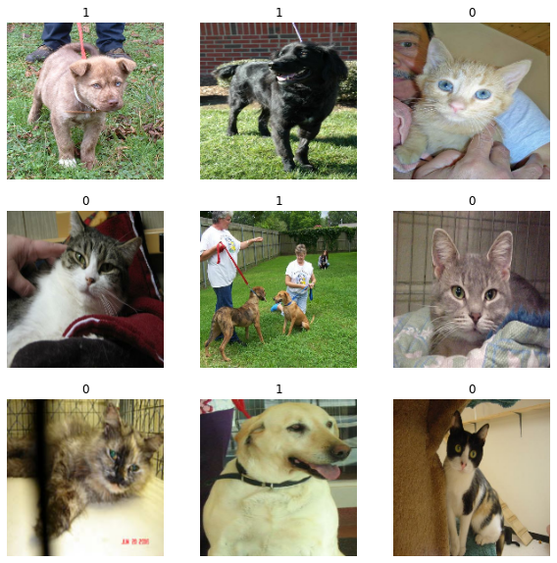

Figure .. Image classification of dogs and cats

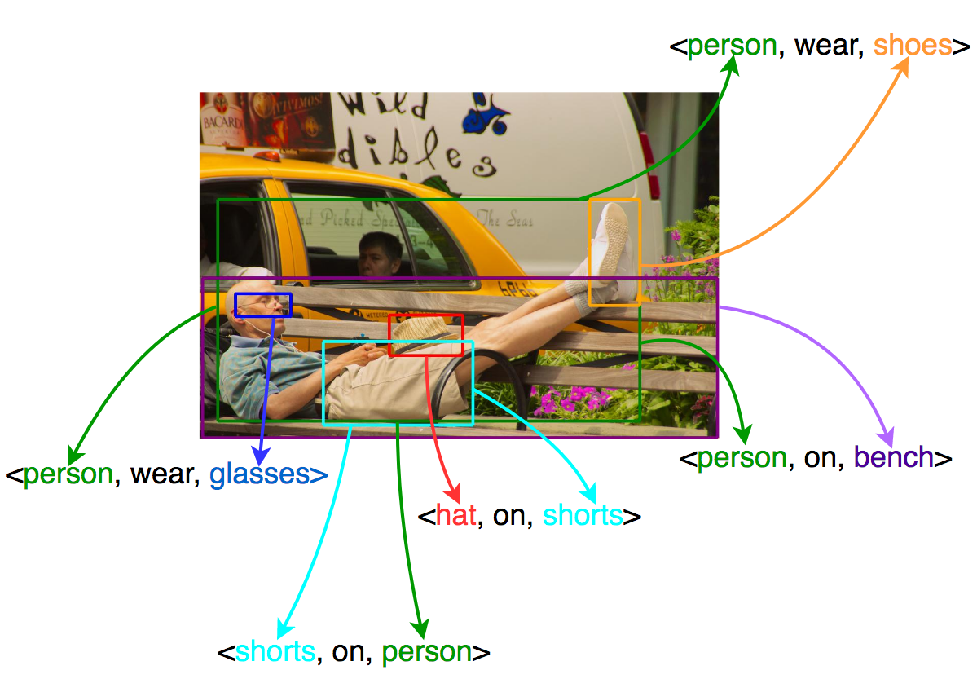

Figure .. Detecting relationships in an image

#### Face recognition

As the name suggests, recognizing faces and attributing them to a certain individual is one of the common computer vision tasks. If trained properly, a model is just as capable of face recognition as we humans are. Figure 1.3 describes how a computer vision algorithm interpretes a human face.

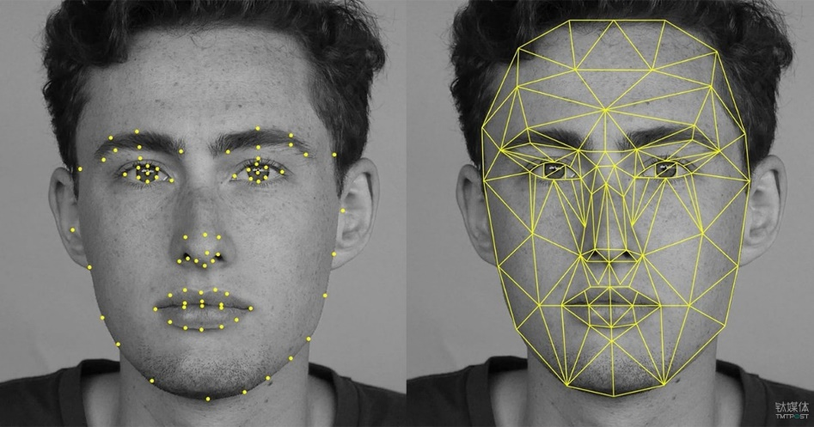

Figure .. Face recognition algorithm

#### Semantic segmentation

Semantic segmentation is the process of identifying similar objects belonging to the same class at the pixel level. For instance, in the figure 1.4, the model has tried to identify similar objects, in this case, people, and color-coded them with a single color to express their belonging to the same class.

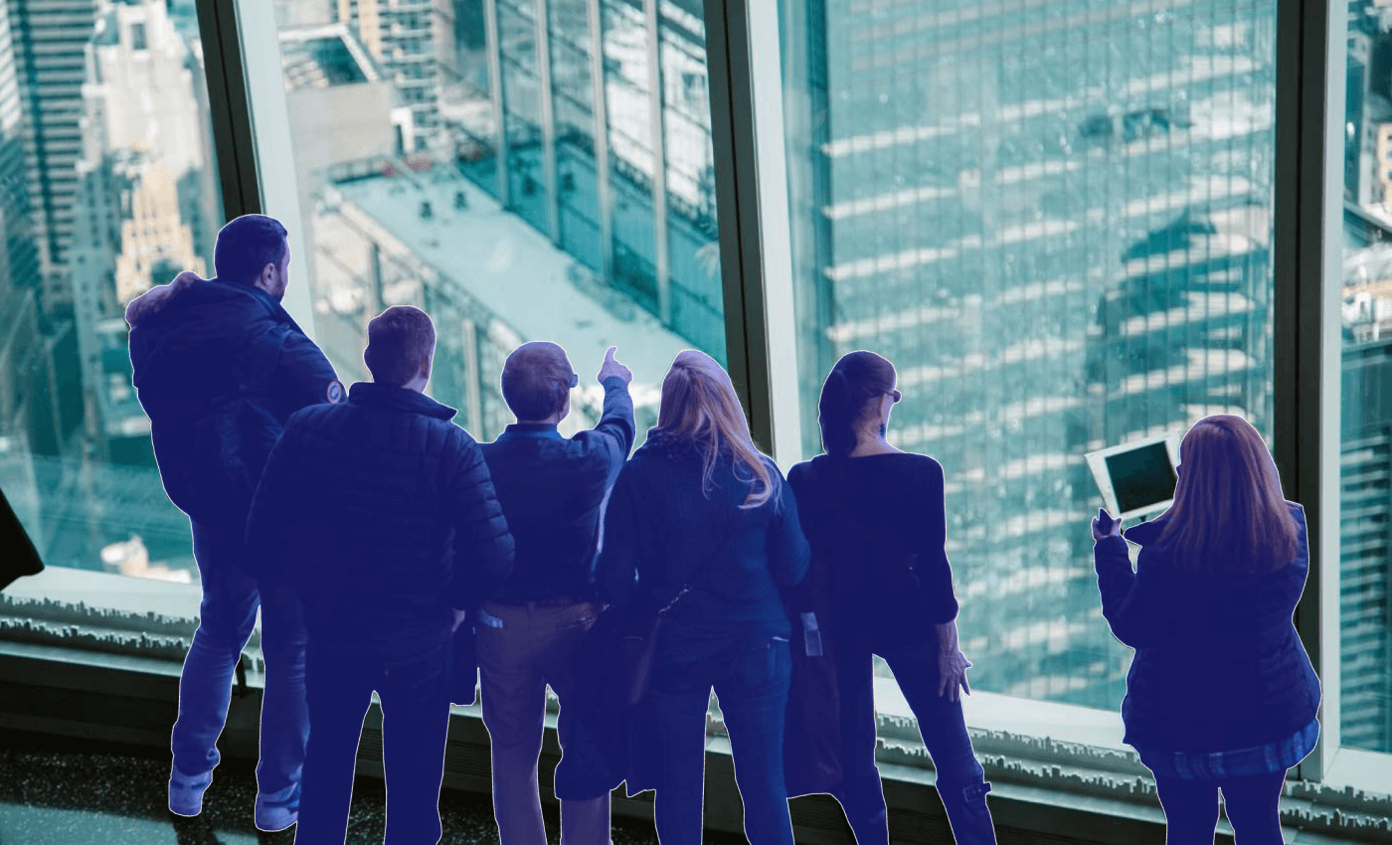

Figure .. Color-coding objects with the same class

### Computer vision tools

The tasks above wouldn’t have been possible without computer vision algorithms, libraries, and tools, the most common of which are:

1. OpenCV: a real-time computer vision and machine learning software library. Provides infrastructure for computer vision applications that assist in face detection, recognition, 3-dimension models extractions, and motion tracking.
2. TensorFlow: a free and open-source software library. Can be used across multiple tasks but has a special focus on training and inference of deep neural networks.
3. YOLO: an algorithm that provides real-time object detection with increased speed and accuracy. Can be used to detect traffic signals, people, parking meters, animals, etc.
4. MATLAB: a programming platform with a computer vision toolbox that supports diverse applications in image, signal, and video processing, deep learning, and machine learning.

## Introduction to Self-Driving Car and Six Levels of Autonomous Driving

An autonomous car is a vehicle capable of sensing its environment and operating without human involvement. A human passenger is not required to take control of the vehicle at any time, nor is a human passenger required to be present in the vehicle at all. An autonomous car can go anywhere a traditional car goes and do everything that an experienced human driver does. The Society of Automotive Engineers (SAE) currently defines 6 levels of driving automation ranging from Level 0 (fully manual) to Level 5 (fully autonomous) as can be briefly understand by looking at figure 1.5.

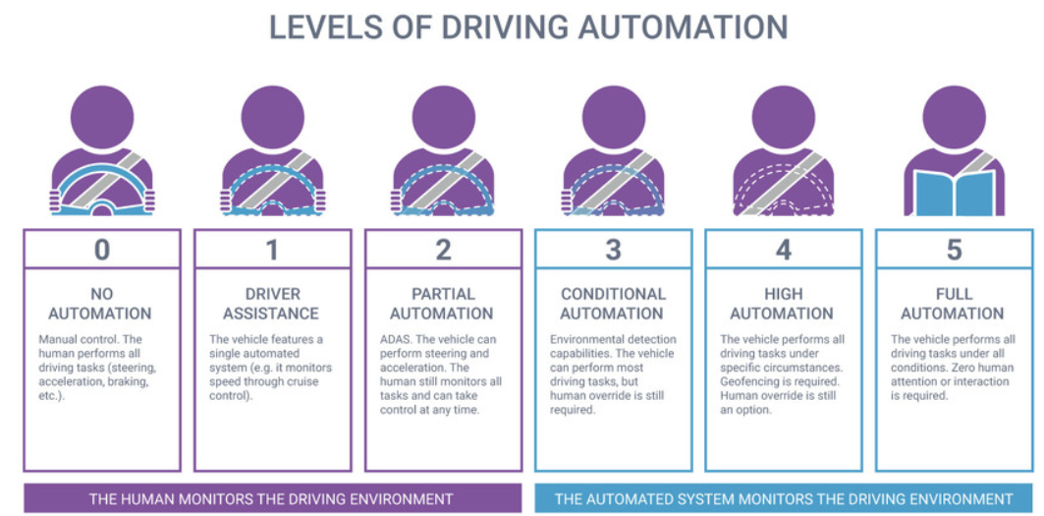

Figure .. Six levels of autonomous driving defined by SAE

1. Level 0 – No Automation: Driver has to manually control the car.
2. Level 1 – Assisted Driving Automation: Level 1 vehicles have one or more assisted driving technologies. A driver is still required to be attentive and manage the car. For example, parking sensors detect objects in a driver’s parking path and alert the driver with a warning sounds. This is designed to assist drivers but the driver must still physically maneuver the car when parking.
3. Level 2 – Partial Automation: Level 2 vehicles have two or more assisted driving technologies that work together simultaneously. For example, a level two vehicle can determine the speed of traffic ahead to coordinate its acceleration and steering on the highway, but the driver is required to be alert at all times to intercept when necessary.
4. Level 3 – Conditional Automation: Level 3 vehicles have limited automation driving functionality under certain conditions. The vehicle has the ability to make certain decisions without human judgement using sensors such as LiDAR. Humans are required to be on standby in case something doesn’t go as intended, but the vehicle takes full control of operating when certain conditions are met during a route.
5. Level 4 – High Automation: Level 4 vehicles have full automation driving technology functionality in most conditions. However, under select circumstances human oversight is required, such as driving on back roads or if a blizzard were to occur and cause poor visibility.
6. Level 5 – Full Automation: Level 5 vehicles have full automation technology and require no involvement of humans. In comparison to level 4 cars, these cars have much more advanced environmental detection systems with the ability to operate under all conditions. An example of this would be the vehicle’s ability to operate autonomously through elevated terrains.

## Computer Vision and Autonomous Driving

The inclusion of computer vision technology can make the autonomous vehicle safe for its passengers as per the researchers and professionals. Computer vision is the core of artificial intelligence technology. Artificial intelligence helps computers to decode and understand the visual data acquired from various sources. It involves automatic visual understanding using artificial intelligence algorithms. In autonomous vehicles, it is used with sensor technology to identify people, cars, and other objects on the road.

1. Recognize objects: There are various moving as well as stationary objects on the road like pedestrians, other vehicles, traffic lights, and more. To avoid accidents or collisions while driving, the vehicle needs to identify various objects. Autonomous vehicles use sensors and cameras to collect data and make 3-dimension maps. This helps to identify and detect objects on the road while driving and makes it safe for its passengers.
2. 3-dimension map creation: The cameras on the vehicle can capture images in real-time. Computer vision uses real-time images to create a 3-dimension map. With the usage of 3-dimension maps, autonomous vehicles can decipher the driving space for risk-free driving and also opt for alternate routes in case of projected collision. This makes driving easy and accident-free for its passengers.
3. Deployment of airbags: The data of surroundings are continuously decoded by computer vision. It can predict any collision or probable accidents in advance. It can deploy airbags well in advance to protect its passengers in case of an unavoidable collision. The safety of the passengers is the top priority and computer vision is intelligent enough to ensure the same.
4. Tracking of cars: Computer vision uses bounding box detention with complex algorithms to detect if the car on the road is the same as before. This is useful to track and also predict behavioral patterns of other drivers and to make driving safe.
5. Lane line detection: Cutting lanes can prove to be a disaster in the case of

self-driving vehicles. Computer vision with Deep learning technology uses segmentation techniques to detect lane lines and to stay in the stipulated lane while self-driving. It can also detect the curves and turns on the road making it a safe experience for its passengers.

1. Low light mode driving: The light condition will differ as per the route, terrain, and time of the day. Self-driving vehicles need to switch between normal and low light modes. The images captured in the low light condition are often blurry and make driving difficult and unsafe. Computer vision with its algorithms can identify the low light condition and adjust to the same while driving.

Computer vision with an AI-based algorithm is the “eye” of self-driving vehicles. The main objective of computer vision is to ensure the safety of its passengers and to deliver a smooth self-driving experience. The technology hasn’t been perfected yet as few limitations need to be fixed. But the pace at which the technology is progressing, intelligent and reliable self-driving car using computer vision will soon be seen on the roads.

## Objectives and Limitation of the Graduation Project

Because the field of computer vision and autonomous driving are so large, a single project cannot cover all of them. Because of that, I will only focus on a tiny part of computer vision. The scope this project is defined by the following objectives and limitations:

1. Objectives: To study computer vision theory and its applications in autonomous driving. And, to apply computer vision in building an autonomous vehicle model that can detect and run smoothly on a lane line.
2. Limitations of the study: My autonomous vehicle model cannot detect traffic objects. And it is designed to run on a controlled environment so if the model is put in another environment, it may not be able to function well.

# COMPUTER VISION THEORY AND APPLICATIONS

## Computer Vision Theory

### Computer vision pipeline

A computer vision pipeline is a series of steps that most computer vision applications will go through. Many vision applications start off by acquiring images and data, then processing that data, performing some analysis and recognition steps, then finally performing an action. The general pipeline is described in figure 2.1.

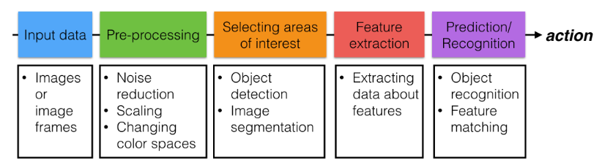

Figure .. Computer vision pipeline

First, the computer receives visual input from an imaging device like a camera. The input is captured as a sequence of images or frames. Then the images are sent to some pre-processing steps that enhance the quality and detail of the image such as noise reduction, scaling, changing color spaces, … Only some areas in the images are interested for a particular problem, the next step is selecting areas of interest using object detection, image segmentation, … Then our software will extract data about the features of that regions. The last step is to predict or recognize the images using information from the extracted data. Related actions will then be executed according to the prediction/recognition results.

#### Standardizing data

Pre-processing images is all about standardizing input images so that you can move further along the pipeline and analyze images in the same way. In machine learning tasks, the pre-processing step is often one of the most important. Figure 2.2 shows an example of a simple algorithm to distinguish between stop signs and other traffic lights.

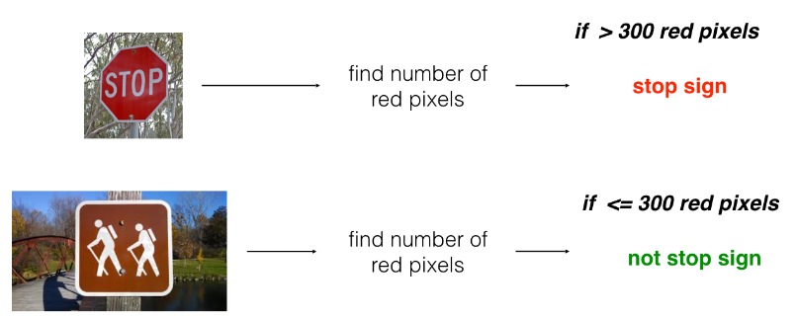

Figure .. Simple classification algorithm

But if the images are different sizes, or even cropped differently, then this counting tactic will likely fail. So, it's important to pre-process these images so that they are standardized before they move along the pipeline. In the figure 2.3, you can see that the images are pre-processed into a standard square size.

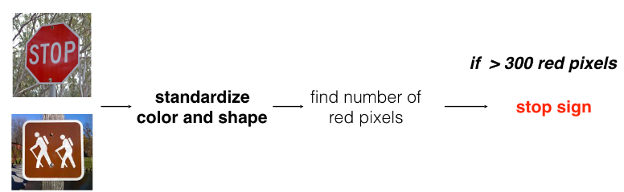

Figure .. Image preprocessing

#### Selecting areas of interest

Selecting areas of interest means filtering out irrelevant areas that may distracts the image processing algorithm and improving the accuracy of the final result.

#### Feature extraction

Feature extraction refers to the process of transforming raw data into numerical features that can be processed while preserving the information in the original data set. It yields better results than applying machine learning directly to the raw data. Feature extraction can be accomplished manually or automatically:

1. Manual feature extraction requires identifying and describing the features that are relevant for a given problem and implementing a way to extract those features. In many situations, having a good understanding of the background or domain can help make informed decisions as to which features could be useful. Over decades of research, engineers and scientists have developed feature extraction methods for images, signals, and text. An example of a simple feature is the mean of a window in a signal.
2. Automated feature extraction uses specialized algorithms or deep networks to extract features automatically from signals or images without the need for human intervention. This technique can be very useful when you want to move quickly from raw data to developing machine learning algorithms. Wavelet scattering is an example of automated feature extraction.

With the ascent of deep learning, feature extraction has been largely replaced by the first layers of deep networks – but mostly for image data. For signal and time-series applications, feature extraction remains the first challenge that requires significant expertise before one can build effective predictive models.

#### Prediction/Recognition

Prediction/Recognition refers to the output of an algorithm after it has been trained on a historical dataset and applied to new data when forecasting the likelihood of a particular outcome.

### Formation of digital image

Digital images are 2-dimension representations of 3-dimension world scenes. If we take a picture of an apple, we will get a 2-dimension image that represents that apple. The image includes details about color, shape, size based on distance and also the light conditions. Figure 2.4 shows how an image is captured by the camera.

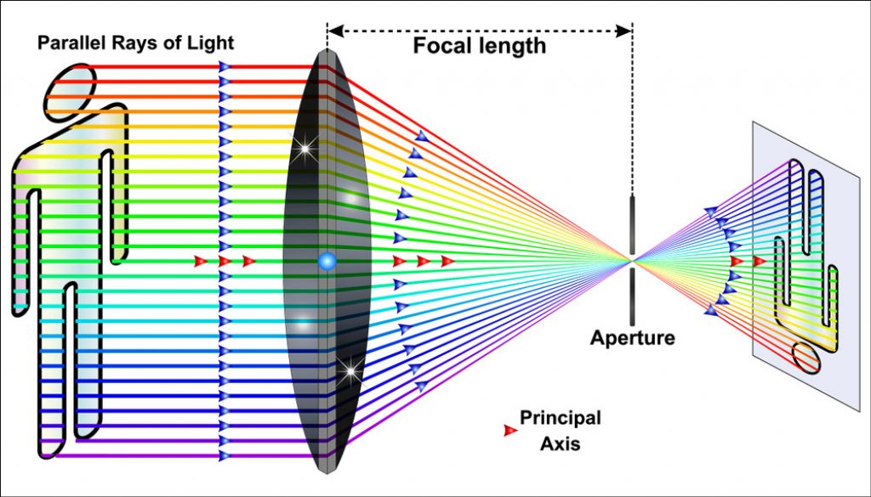

Figure .. How the camera captures an image

When a camera forms an image, it focuses the light that’s reflected off of objects in the world [1]. In figure 2.4, the camera focuses the light that’s reflected off of a person and forms a 2-dimension image at the back of the camera where a sensor or some films would be placed. In fact, the image it forms here will be upside down and reversed because rays of light that enter from the top of an object will continue on that angled path through the lens and end up at the bottom of the formed image. The digital camera will flip this image to turn it into a familiar 2-dimension image of a person.

### Images as numerical data

In digital imaging, a pixel is the smallest addressable element in a raster image, or the smallest addressable element in an all points addressable display device; so it is the smallest controllable element of a picture represented on the screen, see figure 2.5. Each pixel is a sample of an original image; more samples typically provide more accurate representations of the original. The intensity of each pixel is variable. In color imaging systems, a color is typically represented by three or four component intensities such as red, green, and blue, or cyan, magenta, yellow, and black [2].

The pixels in an image is just a numerical value and, we can also change these pixel values. We can multiply every single one by a scalar to change how bright the image is, we can shift each pixel value to the right, and many more operations. Treating images as grids of numbers is the basis for many image processing techniques. Most color and shape transformations are done just by mathematically operating on an image and changing it pixel-by-pixel. Color images are interpreted as 3-dimension cubes of values with width, height, and depth. The depth is the number of colors. Most color images can be represented by combinations of only 3 colors: red, green, and blue values; these are known as RGB images. And for RGB images, the depth is 3, as described in figure 2.6.

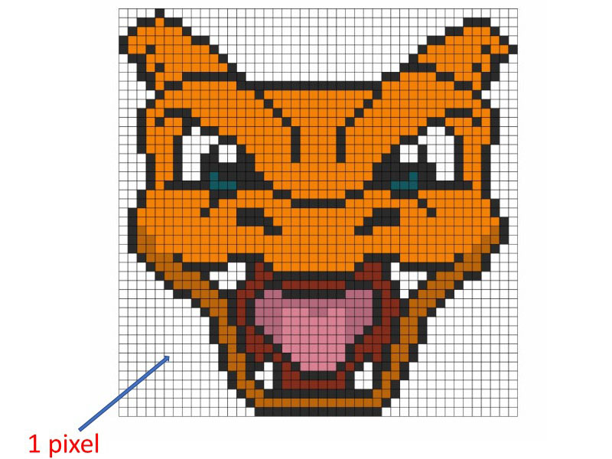

Figure .. Images are constructed by many small picture elements

It is helpful to think of the depth as three stacked, 2-dimension color layers. One layer is Red, one Green, and one Blue. Together they create a complete color image.

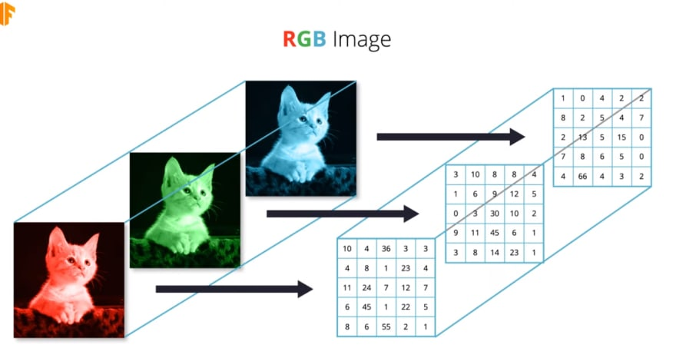

Figure .. Color images are stacks of three different 2-dimension color layers

### Color spaces

A color space is a specific organization of colors. In combination with color profiling supported by various physical devices, it supports reproducible representations of color – whether such representation entails an analog or a digital representation [3]. A color space may be arbitrary, i.e. with physically realized colors assigned to a set of physical color swatches with corresponding assigned color names including discrete numbers in – for example – the Pantone collection, or structured with mathematical rigor as with the NCS System, Adobe RGB and sRGB. A color space is a useful conceptual tool for understanding the color capabilities of a particular device or digital file. When trying to reproduce color on another device, color spaces can show whether shadow/highlight detail and color saturation can be retained, and by how much either will be compromised. A color model is an abstract mathematical model describing the way colors can be represented as tuples of numbers e.g. triples in RGB or quadruples in CMYK; however, a color model with no associated mapping function to an absolute color space is a more or less arbitrary color system with no connection to any globally understood system of color interpretation. Adding a specific mapping function between a color model and a reference color space establishes within the reference color space a definite footprint, known as a gamut, and for a given color model, this defines a color space [4].

#### RBG Color Spaces

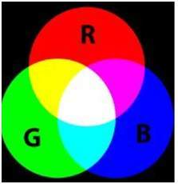

Figure .. RGB color space

Figure 2.7 introduces the RGB color space. It is the most widely used color space. RGB stands for red green and blue. What RGB model states, that each color image is actually formed of three different images. Red image, Blue image, and black image. A normal grayscale image can be defined by only one matrix, but a color image is actually composed of three different matrices. One color image matrix = red matrix + blue matrix + green matrix. This can be best seen in figure 2.8. The common applications of RGB model are: Cathode ray tube, liquid crystal display, plasma display or LED display such as a television, e.t.c…

#### HSV and HSL color space

HSL (for hue, saturation, lightness) and HSV (for hue, saturation, value; also known as HSB, for hue, saturation, brightness) are alternative representations of the RGB color model, designed in the 1970s by computer graphics researchers to more closely align with the way human vision perceives color-making attributes. In these models, colors of each hue are arranged in a radial slice, around a central axis of neutral colors which ranges from black at the bottom to white at the top. The HSL models the way different paints mix together to create color in the real world, with the lightness dimension resembling the varying amount of black or

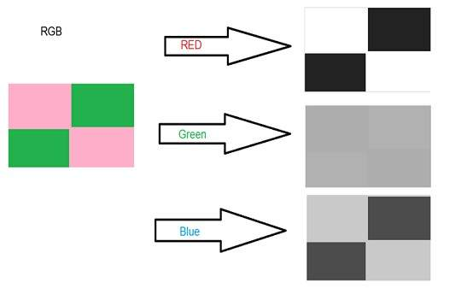

Figure .. How an image in RBG represented in three layers of color intensity

white paint in the mixture. Fully saturated colors are placed around a circle at a lightness value of a half, with a lightness value of 0 or 1 corresponding to fully black or white, respectively. Meanwhile, the HSV representation models how colors appear under light. The difference between HSL and HSV is that a color with maximum lightness in HSL is pure white, but a color with maximum value/brightness in HSV is analogous to shining a white light on a colored object e.g. shining a bright white light on a red object causes the object to still appear red, just brighter and more intense, while shining a dim light on a red object causes the object to appear darker and less bright.

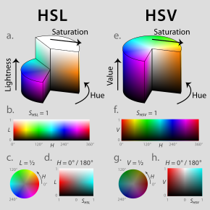

Figure .. HSV and HSL color space

As can be seen in the figure 2.9, HSL and HSV are both cylindrical geometries, with hue, their angular dimension, starting at the red primary at 0°, passing through the green primary at 120° and the blue primary at 240°, and then wrapping back to red at 360°. In each geometry, the central vertical axis comprises the neutral, achromatic, or gray colors ranging, from top to bottom, white at lightness 1 (value 1) to black at lightness 0 (value 0). In both geometries, the additive primary and secondary colors—red, yellow, green, cyan, blue and magenta—and linear mixtures between adjacent pairs of them, sometimes called pure colors, are arranged around the outside edge of the cylinder with saturation 1. These saturated colors have lightness 0.5 in HSL, while in HSV they have value 1. Mixing these pure colors with black leaves saturation unchanged. In HSL, saturation is also unchanged by tinting with white, and only mixtures with both black and white have saturation less than 1. In HSV, tinting alone reduces saturation.

### Filters

In image processing, filters are used to filter out unwanted or irrelevant information in an image or to amplify features like object boundaries or other distinguishing traits, as described in the figure 2.10.

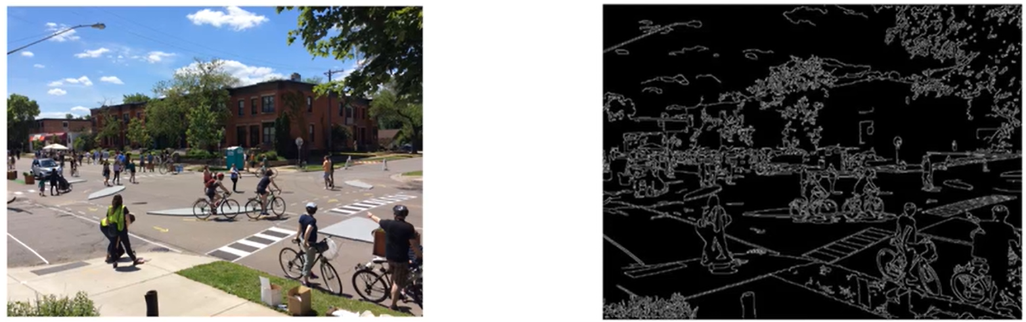

Figure .. Image after applying filter

A filter is a matrix of numbers that modifies an image. The matrix shown in the figure 2.11 is an example of a high-pass filter that does edge detection:

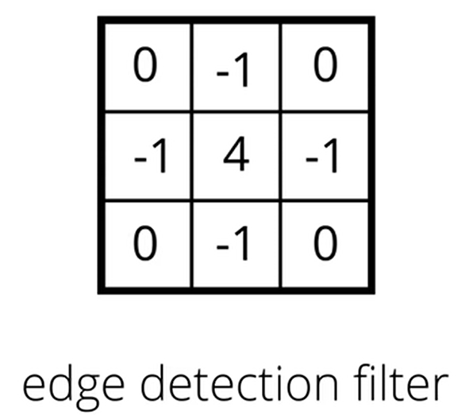

Figure .. Edge detection filter

All elements of the matrix need to sum to zero because this filter is computing the difference or change between neighboring pixels. Differences are calculated by subtracting pixel values from one another (in this case, subtracting the value of the pixels that surround a center pixel) and if these kernel values did not add up to zero that would mean that this calculated difference will be either positively or negatively weighted, which will have the effect of brightening or darkening the entire filtered image respectively. The filter is applied by convolving the input image F(x, y) with the filter. This process of producing the filtered image is called kernel convolution, as described in figure 2.12.

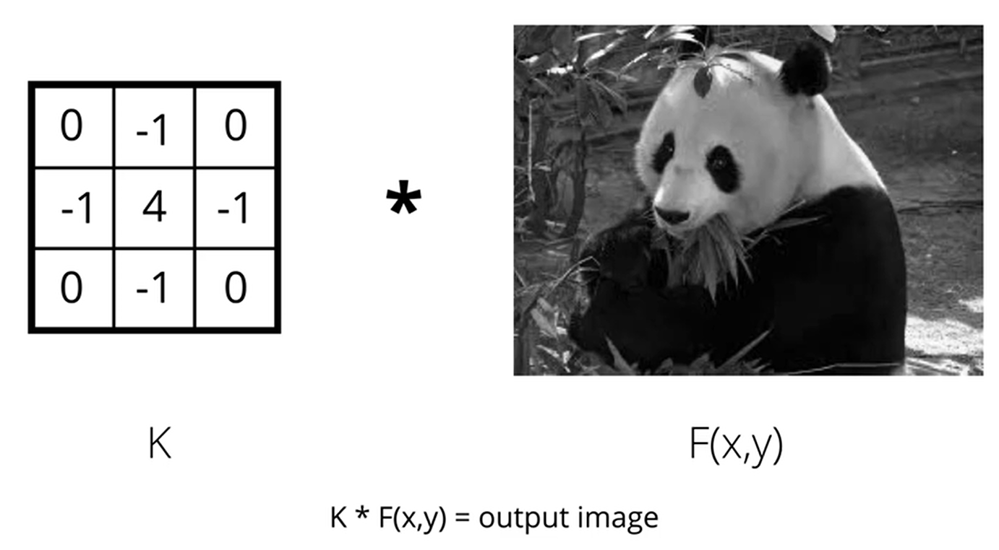

Figure .. Applying filter to images mathematically

Convolution is the process of adding each element of the image to its local neighbors, weighted by the kernel. This is related to a form of mathematical convolution. The matrix operation being performed—convolution—is not traditional matrix multiplication, despite being similarly denoted by *. For example, if we have two three-by-three matrices, the first a kernel, and the second an image piece, convolution is the process of flipping both the rows and columns of the kernel and multiplying locally similar entries and summing. The element at coordinates [2, 2] (that is, the central element) of the resulting image would be a weighted combination of all the entries of the image matrix, with weights given by the kernel:



The other entries would be similarly weighted, where we position the center of the kernel on each of the boundary points of the image, and compute a weighted sum. The values of a given pixel in the output image are calculated by multiplying each kernel value by the corresponding input image pixel values. If the kernel is symmetric then place the center of the kernel on the current pixel. The kernel will overlap the neighboring pixels around the origin. Each kernel element should be multiplied with the pixel value it overlaps with and all of the obtained values should be summed. This resultant sum will be the new value for the current pixel currently overlapped with the center of the kernel. If the kernel is not symmetric, it has to be flipped both around its horizontal and vertical axis before calculating the convolution as above.

#### High-pass Filter

High-pass filters are used to make an image appear sharper and enhance high-frequency parts of an image, which are areas where the levels of intensity in neighboring pixels rapidly change like from very dark to very light pixels. Since we're looking at patterns of intensity, the filters we'll be working with will be operating on grayscale images that represent this information and display patterns of lightness and darkness in a simple format. In figure 2.13, where there is no change or little change in intensity in the original picture, (such as the large

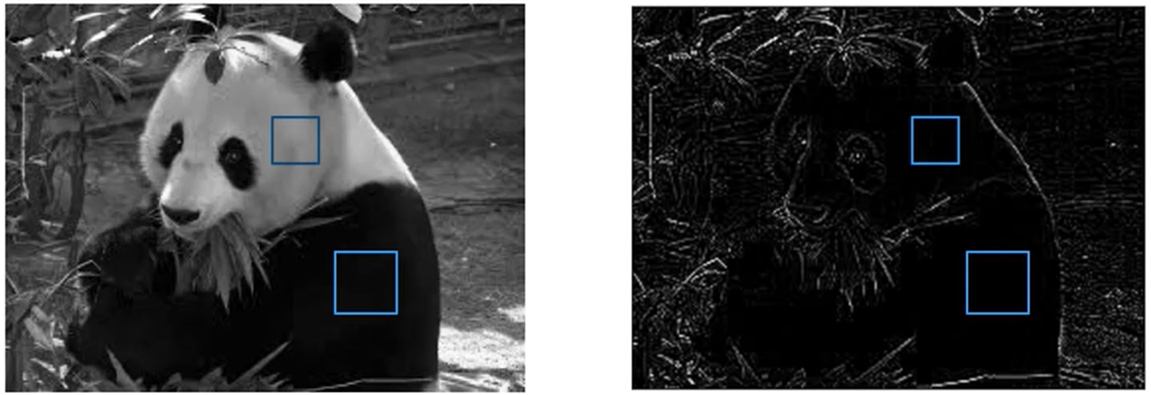

Figure .. Regions with little change in intensity

areas of dark and light), a high-pass filter will black these areas out and turn the pixels black.

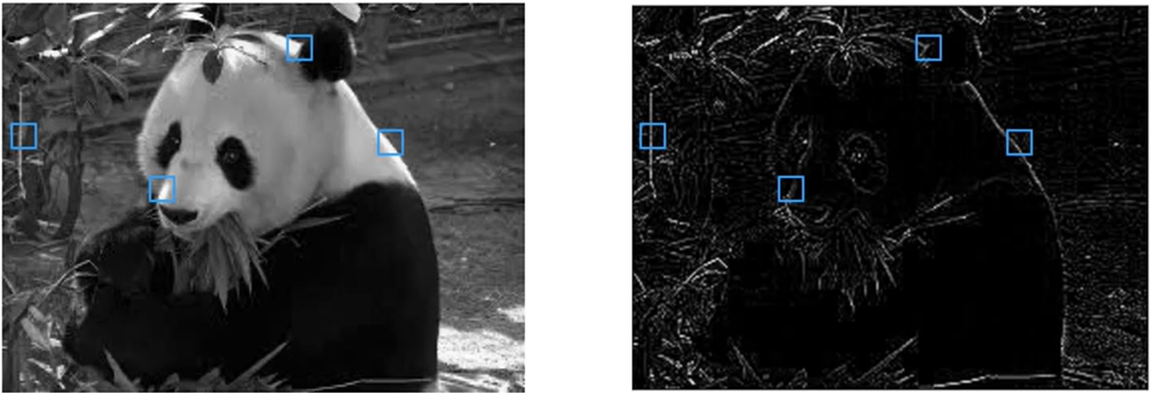

Figure .. Regions with intense changed in frequency

As can be seen in figure 2.14, in these areas where a pixel is way brighter than its immediate neighbors, the high-pass filter will enhance that change and create a line. This is the effect of emphasizing edges. Edges or just areas in an image where the intensity changes very quickly and these edges often indicate object boundaries.

#### Low-pass Filter

Low-pass filter is generally used to filter out noise. Image noise is random variation of brightness or color information in images, and is usually an aspect of electronic noise. It can be produced by the image sensor and circuitry of a scanner or digital camera. Image noise can also originate in film grain and in the unavoidable shot noise of an ideal photon detector. Image noise is an undesirable by-product of image capture that obscures the desired information. Figure 2.15 demonstates an image with noise.

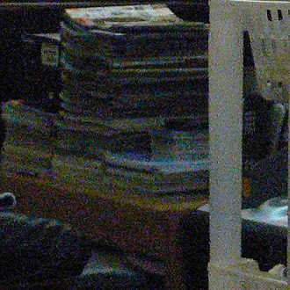

Figure .. Noise in an image

To reduce the noise, we can apply the averaging filter which is described in the figure 2.16. The all values in the filter should be sum up to 1 to avoid brightening or darkening the image so we multiply all values in the filter with one-nineth.

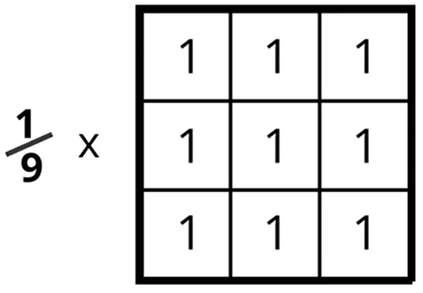

Figure .. Averaging filter

Figure 2.17 show the filtered image after using averaging filter. The image is now smoothed and the noise is partly reduced.

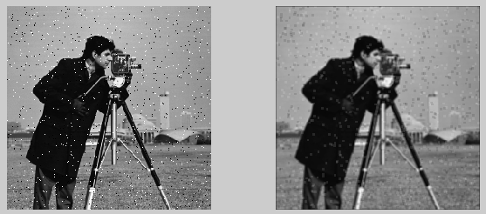

Figure .. Noise in image is smoothed by low-pass filter

### Frequency in images

We have an intuition of what frequency means when it comes to sound. High-frequency is a high pitched noise, like a bird chirp or violin. And low frequency sounds are low pitch, like a deep voice or a bass drum. For sound, frequency actually refers to how fast a sound wave is oscillating; oscillations are usually measured in cycles/s (Hz), and high pitches and are made by high-frequency waves. Examples of low and high-frequency sound waves are pictured below. As can be seen in the figure 2.18, on the y-axis is amplitude, which is a measure of sound pressure that corresponds to the perceived loudness of a sound, and on the x-axis is time.

#### High and low frequency

Frequency in images is a rate of change. Images change in space, and a high frequency image is one where the intensity changes a lot. And the level of brightness changes quickly from one pixel to the next. A low frequency image may be one that is relatively uniform in brightness or changes very slowly. Figure 2.19 show different frequency types in different areas.

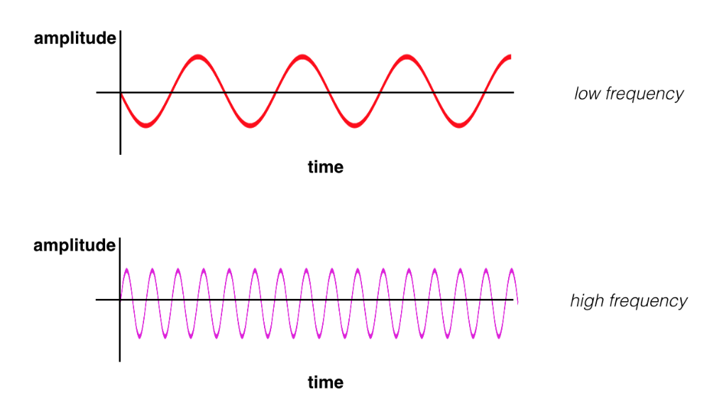

Figure .. High and low frequency

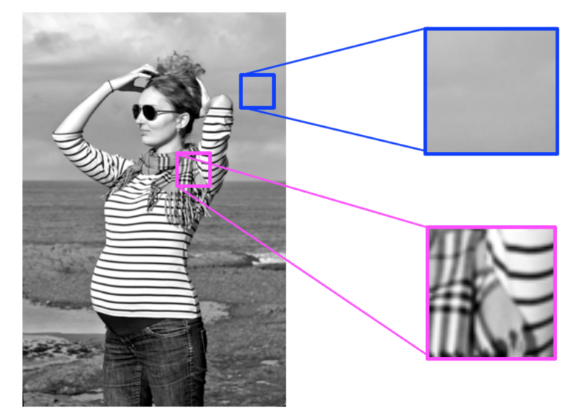

Figure .. Blue area: low frequency. Pink area: high frequency

Most images have both high-frequency and low-frequency components. In the image above, on the scarf and striped shirt, we have a high-frequency image pattern; this part changes very rapidly from one brightness to another. Higher up in this same image, we see parts of the sky and background that change very gradually, which is considered a smooth, low-frequency pattern. High-frequency components also correspond to the edges of objects in images, which can help us classify those objects.

### Gaussian blur

In image processing, a Gaussian blur is the result of blurring an image by a Gaussian function. It is a widely used effect in graphics software, typically to reduce image noise and reduce detail. The visual effect of this blurring technique is a smooth blur resembling that of viewing the image through a translucent screen, distinctly different from the bokeh effect produced by an out-of-focus lens or the shadow of an object under usual illumination. Gaussian smoothing is also used as a pre-processing stage in computer vision algorithms in order to enhance image structures at different scales. Mathematically, applying a Gaussian blur to an image is the same as convolving the image with a Gaussian function. This is also known as a two-dimensional Weierstrass transform. By contrast, convolving by a circle would more accurately reproduce the bokeh effect. Since the Fourier transform of a Gaussian is another Gaussian, applying a Gaussian blur has the effect of reducing the image's high-frequency components; a Gaussian blur is thus a low-pass filter. The Gaussian blur is a type of image-blurring filter that uses a Gaussian function for calculating the transformation to apply to each pixel in the image. The formula of a Gaussian function in one dimension is:

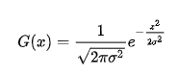

, and in two dimensions:

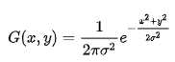

where x is the distance from the origin in the horizontal axis, y is the distance from the origin in the vertical axis, and σ is the standard deviation of the Gaussian distribution. It is important to note that the origin on these axes are at the center (0, 0). When applied in two dimensions, this formula produces a surface whose contours are concentric circles with a Gaussian distribution from the center point.

### Dilation and erosion

Dilation and erosion are known as morphological operations. They are often performed on binary images, similar to contour detection. Dilation enlarges bright, white areas in an image by adding pixels to the perceived boundaries of objects in that image. Erosion does the opposite: it removes pixels along object boundaries and shrinks the size of objects. Often these two operations are performed in sequence to enhance important object traits.

#### Dilation

To dilate an image in OpenCV, you can use the dilate function and three inputs: an original binary image, a kernel that determines the size of the dilation (None will result in a default size), and a number of iterations to perform the dilation (typically = 1). In the below example, we have a 5x5 kernel of ones, which move over an image, like a filter, and turn a pixel white if any of its surrounding pixels are white in a 5x5 window. We’ll use a simple image of the cursive letter “j” as an example.

#### Erosion

To erode an image, we do the same but with the erode function. Eroded and dilated images are shown in the figure 2.20.

#### Opening

As mentioned above, these operations are often combined for desired results.

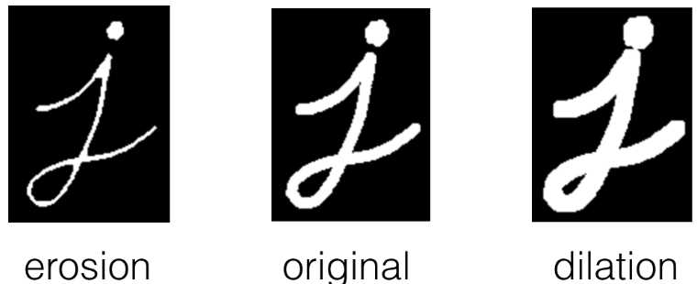

Figure .. Erosion and Dilation

One such combination is called opening, which is erosion followed by dilation. This is useful in noise reduction in which erosion first gets rid of noise then dilation enlarges the object again, but the noise will have disappeared from the previous erosion, as described in figure 2.21.

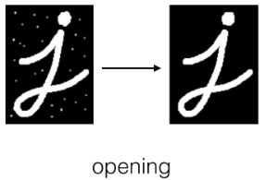

Figure .. Opening

To implement this in OpenCV, we use the function morphologyEx with our original image, the operation we want to perform, and our kernel passed in.

#### Closing

As shown in the figure 2.22, closing is the reverse combination of opening; it’s dilation followed by erosion, which is useful in closing small holes or dark areas within an object.

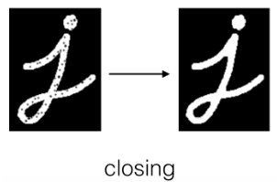

Figure .. Closing

## Applying Computer Vision to Build Lane Detecting Algorithm

### Pipeline

In this project, I use regular A4 white paper as the road for the autonomous vehicle to run on. It means that the road will be completely white and other areas will be black. Our task is to help to robot to detect the lane and run only on that detected lane. The solution is listed step-by-step as follows:

1. Image capturing: frames of images are captured by the camera as inputs for image processing.
2. Grey scale conversion: convert the color image to grey scale image.
3. Image resizing: remove unwanted areas in the input image.
4. Gamma correction: correct lightness of input images to facilitate other image processing tasks.
5. Image thresholding: create a mask that separate the path with other objects.
6. Image warping: digitally manipulating an image such that any shapes portrayed in the image have been significantly distorted. Warping is used for correcting image distortion.
7. Finding curve: estimate the curve by calculating the sum of bright pixels at the left and right side.
8. Optimizing curve: optimize the calculated curve for more accurate steering of the motors.
9. Motors controlling: Control the motor according to detected lane curve.

Figure 2.23 is the flowchart of the lane detecting algorithm.

### Grey scale conversion and image resizing

The main reason why we convert color image to grayscale representation and resizing input image is that grayscale simplifies the algorithm and reduces computational requirements. In RGD color space, color images are formed by overlapping three layers of red, green and blue channels together. Because our problem only concerns the brightness of the input image i.e. it detects the brightness difference of the road and other objects so we can convert color images, which have three layers, to greyscale images, which have only one layer. This process significantly reduces the size of the input image. The same idea is applied to image resizing, this process also reduces the size of images that helps the processing process much easier and faster.

### Gamma correction

Brightness and contrast adjustments is an image processing task that is used to correct the lightness and contrast of input images by mapping each and every picture element of the input image with a function to produce an output image [5]. There are two kinds of function that can be used: linear transform and gamma correction.

#### Brightness and contrast adjustments by linear transform

In this kind of image processing transform, each output pixel's value depends on only the corresponding input pixel value. Two commonly used point processes are multiplication and addition with a constant:

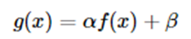

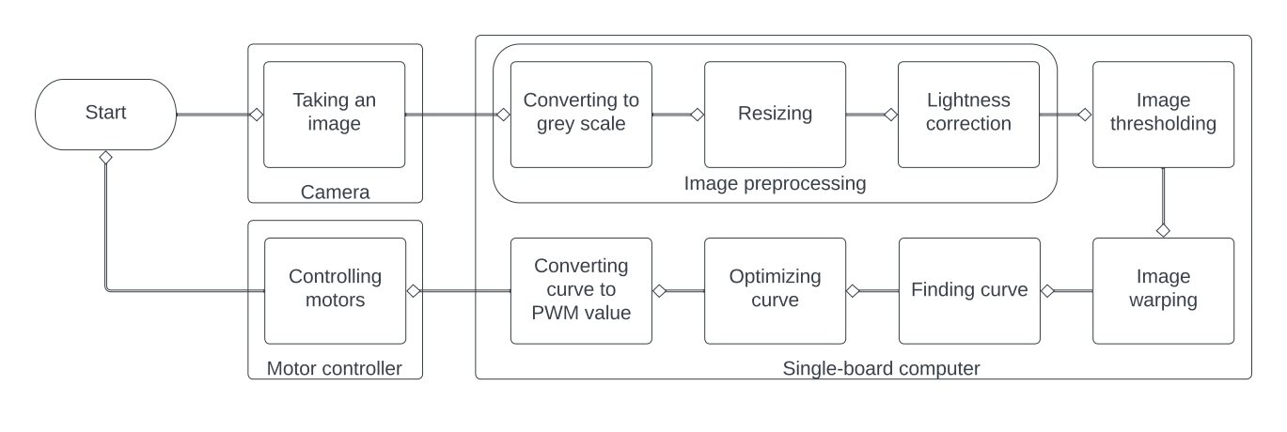

Figure .. Flowchart of the lane detecting algorithm

where the parameters α>0 and β are the *gain* and *bias* parameters; these parameters are said to control contrast and brightness respectively. Figure 2.24 shows the result of image linear transformation.

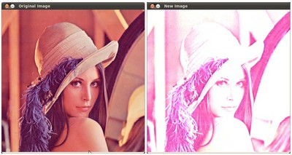

Figure .. Brightness and contrast correction with linear transform

Increasing (/decreasing) the β value will add (/subtract) a constant value to every pixel. Because pixel value is from 0 to 255 so if it is outside of the [0; 255] range, it will be saturated (in other words, a pixel value higher (/lesser) than 255 (/0) will be clamped to 255 (/0)).

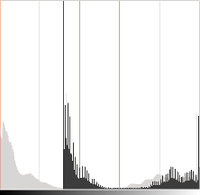

Figure .. Histogram of color level after applying linear transform

The histogram in the figure 2.25 represents for each color level the number of pixels with that color level. A dark image will have many pixels with low color value and thus the histogram will present a peak in its left part. When adding a constant bias, the histogram is shifted to the right as we have added a constant bias to all the pixels. The α parameter will modify how the levels spread. If α<1, the color levels will be compressed and the result will be an image with less contrast.

As can be seen in figure 2.26, it can occur that playing with the β bias will improve the brightness but in the same time the image will appear with a slight veil as the contrast will be reduced. The α gain can be used to diminue this effect but due to the saturation, we will lose some details in the original bright regions.

#### Brightness and contrast adjustments by gamma correction

Gamma correction can be used to correct the brightness of an image by using a

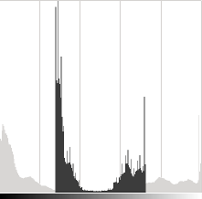

Figure .. The value α controls the spread of color level

non-linear transformation between the input values and the mapped output values:

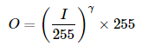

where I is the input image and O is the output image. As this relation is non linear, the effect will not be the same for all the pixels and will depend to their original value. When γ<1, the original dark regions will be brighter and the histogram will be shifted to the right whereas it will be the opposite with γ>1.

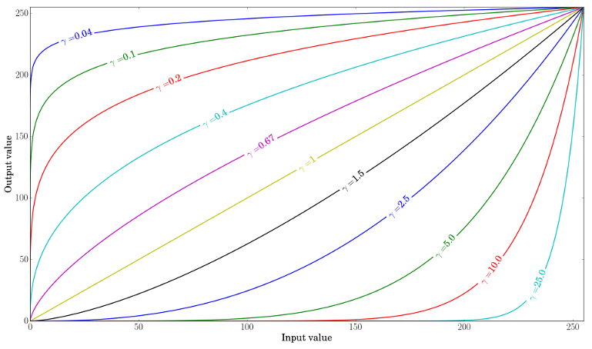

Figure .. Value of pixels after gamma correction

As can be seen in figure 2.27, the plot shows that gamma correction method is much better than linear transformation when we need to correct an underexposed image. Gamma correction algorithm makes the dark pixel much brighter than it does with the pixels that are already bright. Image in figure 2.28 is corrected with α = 1.3 and β = 40. The overall brightness has been improved but you can notice that the clouds are now greatly saturated due to the numerical saturation of the implementation used. Image in figure 2.29 is corrected with γ=0.4. The gamma correction tends to add less saturation effect as the mapping is non linear and there is no numerical saturation possible as in the previous method.

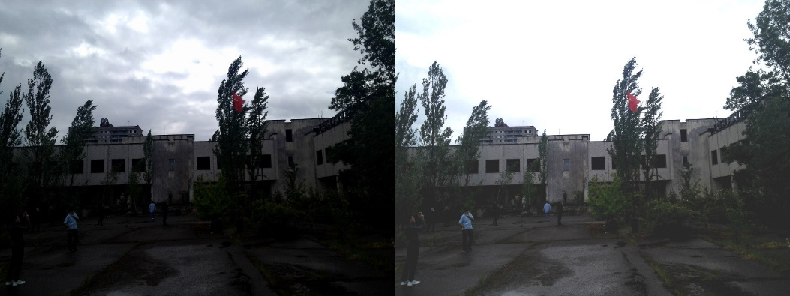

Figure .. Correct an underexposed image with linear transform

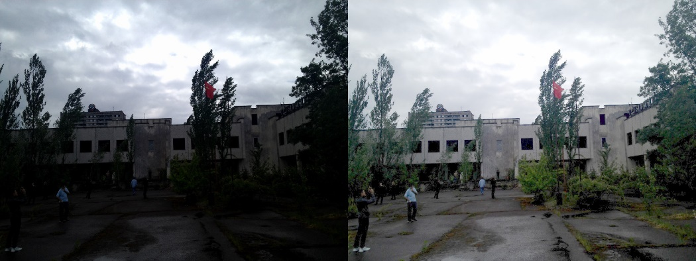

Figure .. Correct an underexposed image with gamma correction

Figure 2.30 compares the histograms for the three images (the y-ranges are not the same between the three histograms). You can notice that most of the pixel values are in the lower part of the histogram for the original image. After α, β correction, we can observe a big peak at 255 due to the saturation as well as a shift in the right. After gamma correction, the histogram is shifted to the right but the pixels in the dark regions are more shifted (see the gamma curves figure) than those in the bright regions.

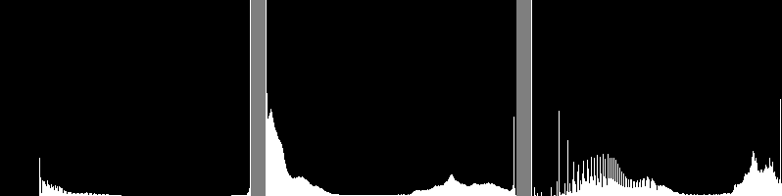

Figure .. Left: histogram after alpha, beta correction; Center: histogram of the original image; Right: histogram after the gamma correction

### Image thresholding

Image thresholding is the simplest method of segmenting images. In digital image processing and computer vision, image segmentation is the process of partitioning a digital image into multiple image segments, also known as image regions or image objects. The goal of segmentation is to simplify and/or change the representation of an image into something that is more meaningful and easier toanalyze. Image segmentation is typically used to locate objects and boundaries in images. More precisely, image segmentation is the process of assigning a label to every pixel in an image such that pixels with the same label share certain characteristics. From a grayscale image, thresholding can be used to create binary images as in the figure 2.31 and 2.32.

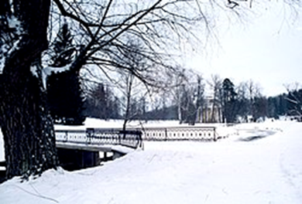

Figure .. Original image

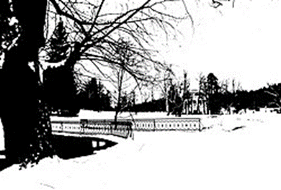

Figure .. The binary image created by thresholding the original image

The simple thresholding methods replace each pixel in an image with a black pixel if the image intensity is less than a fixed value called the threshold **T**, or a white pixel if the pixel intensity is greater than that threshold. In the example in figures above, this results in the dark tree becoming completely black, and the bright snow becoming completely white [6]. Figure 2.33 describes some simple thresholding methods. These includes:

1. Binary thresholding: If pixel intensity is greater than the set threshold, value set to 255, else set to 0 (black).
2. Inverted binary thresholding: If pixel intensity is greater than the set threshold, value set to 0, else set to 255 (white).
3. Truncated thresholding: If pixel intensity value is greater than threshold, it is truncated to the threshold. The pixel values are set to be the same as the threshold. All other values remain the same.

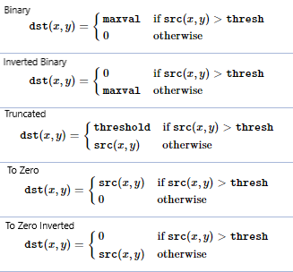

Figure .. Some simple thresholding methods algorithms

1. To zero thresholding: Pixel intensity is set to 0, for all the pixels’ intensity, less than the threshold value.
2. To zero inverted thresholding: Pixel intensity is set to 0, for all the pixels’ intensity, more than the threshold value.

Figure 2.34 shows the results of different thresholding methods.

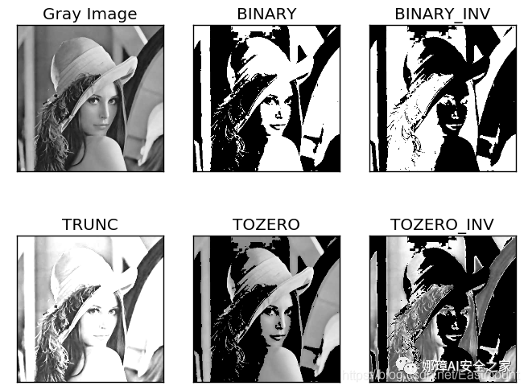

Figure .. Simple thresholding methods examples

We use thresholding method to segment the road from others. As previously mentioned, we use regular A4 white paper as the path for the autonomous robot to run on. To detect the path, we use the thresholding function that create a mask which seperates the path with other things. In the code, the first step is to convert the input frames color space from RGB color space to HSV color space because this process helps us to separate the lightness of the image frames. Next, we set the upper and lower threshold for hue, saturation and lightness value so that it creates a mask which segments the path with other things. Figure 3.35 shows the original image, mask created by thresholding and the image after applying the mask.

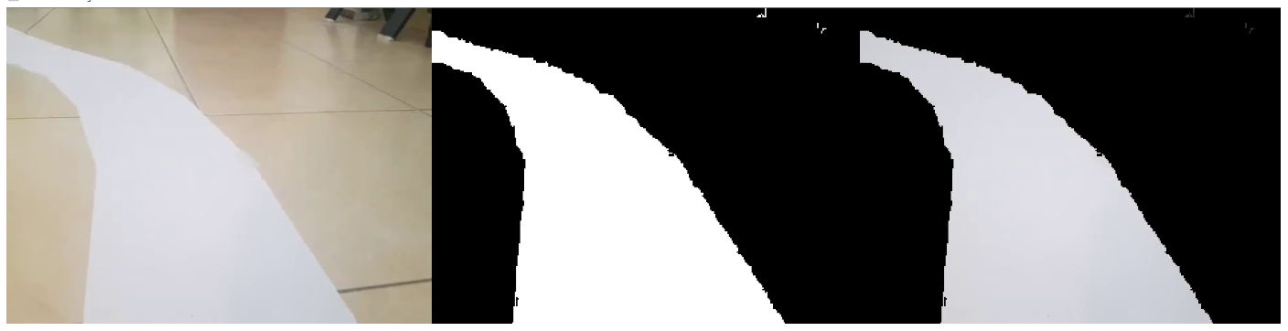

Figure .. a) Original image; b) Mask; c) Image after applying mask

### Image warping

Image warping is the process of digitally manipulating an image such that any shapes portrayed in the image have been significantly distorted. Warping may be used for correcting image distortion as well as for creative purposes. Figure 2.36 describes how the image wraping process is done.

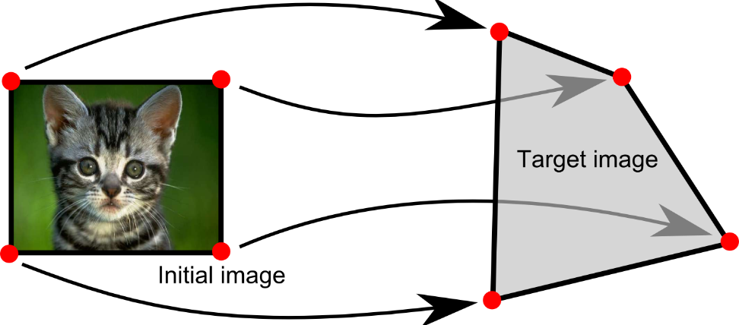

Figure .. Image warping example

Pure warping means that points are mapped to points without changing the colors. This can be based mathematically on any function from (part of) the plane to the plane. If the function is injective the original can be reconstructed. If the function is a bijection any image can be inversely transformed.

Some methods of image warping are:

1. Images may be distorted through simulation of optical aberrations.
2. Images may be viewed as if they had been projected onto a curved or mirrored surface. (This is often seen in ray traced images.)
3. Images can be partitioned into polygons and each polygon distorted.
4. Images can be distorted using morphing.

The most obvious approach to transforming a digital image is the forward mapping. This applies the transform directly to the source image, typically generating unevenly-spaced points that will then be interpolated to generate the required regularly-spaced pixels. However, for injective transforms reverse mapping is also available. This applies the inverse transform to the target pixels to find the unevenly-spaced locations in the source image that contribute to them. Estimating them from source image pixels will require interpolation of the source image. We can use image warping to change the input image frame so that the image looks as if we were watching it from the top. This is known as a bird eye view and it is important because it will allow us to easily find the curve. To warp the image, we need to define the initial points. These points we can determine manually. So to make this process easier we could use track bars to experiment with different values. The idea is to get a rectangle shape when the road is straight. Figure 2.37 shows the result of image warping the original image.



Figure .. a) Original image after applying mask; b) Image warping; c) Warped image after applying mask

### Finding curve

Finding the curve in our path is the most important part of the algorithm. To do this we will use the summation of pixels. Given that our warped image is now binary, in other words, it has either black or white pixels, we can sum the pixel values in the y direction as can be seen in the figure 2.38.

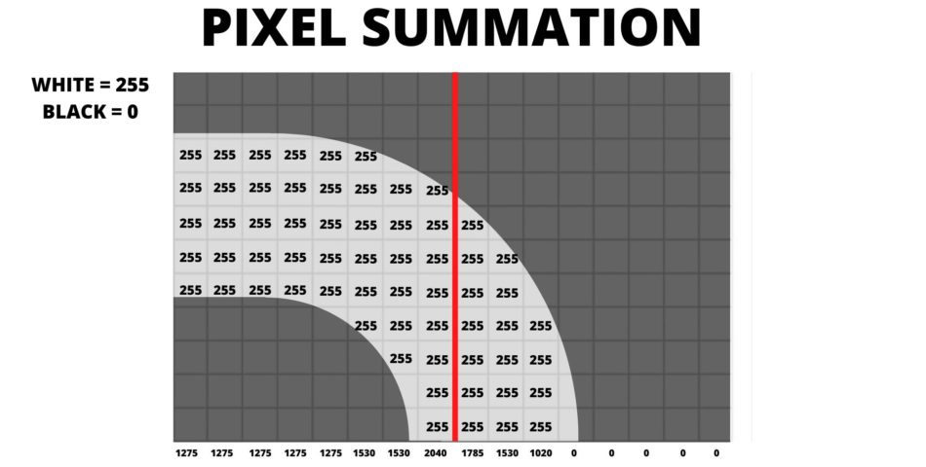

Figure .. Pixel summation in y direction

All the white pixels with value of 255 and all the black with value of 0. Now if we sum the pixels in first column it yeilds the value of 1275. We apply this method to each of the columns. In our original image, we have 480 pixels in the width. Therefore, we will have 480 values. After summation we can look at how many values are above a certain threshold hold let’s say 1000 on each side of the center red line. In the above example we have 8 columns on the left and 3 columns on the right. This tells us that the curve is towards left. This is the basic concept, though we will add a few more things to improve this and get consistent results. But if we look deeper into this we will face a problem as described in figure 2.39.

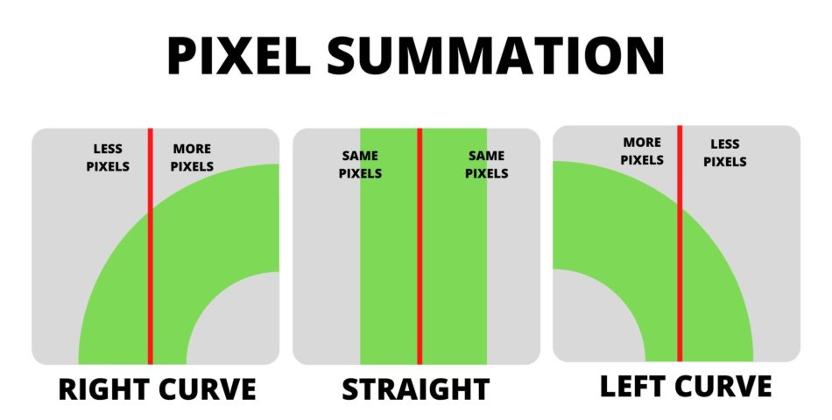

Figure .. Pixel summation result in three different cases

We can clearly see that when the curve is right the number of pixels on the right hand side are more than the left and vise versa. And when its straight the number of pixels are approximately same on both sides. This is good but there are cases when this method would fail. Two cases are described in figure 2.40.

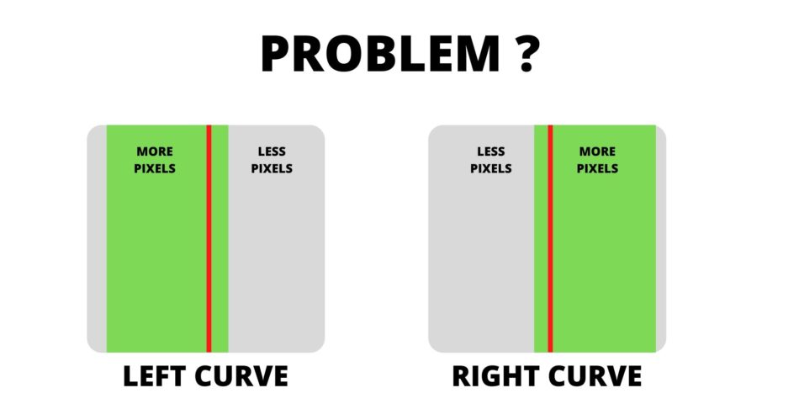

Figure .. The problem when the center line is not in the middle of the road

Here even though there is no curve since more pixels are present on one side the algorithm will output either left or right curve. So to fix this problem we adjust the center line. Figure 2.41 shows the solution for the previously mentioned problem. The problem new comes down to find the centor of the base which will give us the center line and then we compare the pixels on both side. Both processes can be computed with the same function as described below:

1. Take image as an input then sum all the pixels in the y direction.
2. Filter noise images by set a threshold value which will be the minimum value required for any column to qualify as part of the path and not noise.
3. Get the value of curvature by finding the indices of all the columns that have value more than our defined threshold and average them.

The base value is now the average base point of our image. Figure 2.42 shows the calculated average base point of the whole image.

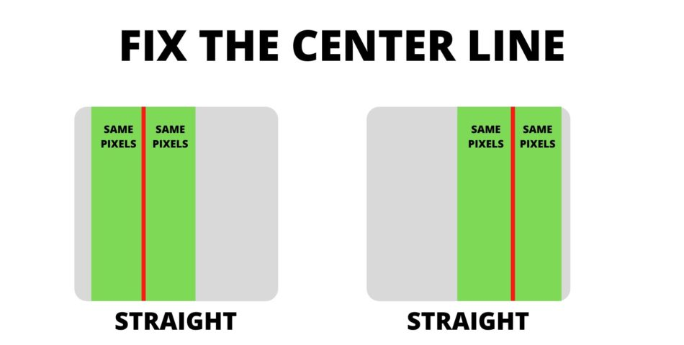

Figure .. Fix the center line

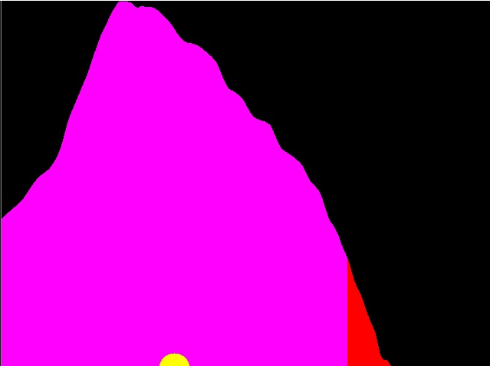

Figure .. Average base point of all the image

### Optimizing curve

To get the lane curve, we can subtract the average base point of only the front area of the image from the average base point of all the image to get the curve value. For example, if we assume the center is at 240 then the curve value is 227- 240 = -13. Here the minus sign indicates the curve is towards the left side and the value 13 indicates the intensity of curve. But this method is not accurate since the middle can change. So to find the middle point, we can simply use the function we just created, but this time instead of the complete image we will apply the histogram technique only on the bottom one-fourth part of the image. This is because we are interested in the average of the base so we don’t want to average the pixels above one-fourth the image. To achieve this, we can add an input argument of region and based on the input value of this we can decide whether to average the whole image or part of it. So if the region is 1 the whole image will be average and if the region is 4 then on the 4th portion at the bottom will be averaged. Figure 2.44 shows the average base point of the bottom part.

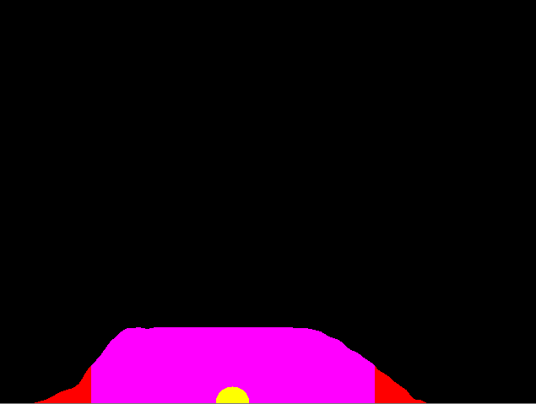

Figure .. Average base point of the near region in front of the car

Now let us say that the average value we get is 278. This means the actual center of our image is 278 instead of 240. Now we can subtract our average value that we got before from this middle point: 227 – 278 = -51. Earlier our value was -13 and now we got -51. Looking at the warped image we can tell that the intensity of the curve is high therefore this confirms that the second method gives us better result. Once we have the curve value we will append it in a list so that we can average this value. Averaging will allow smooth motion and will avoid any dramatic movements. The result of finding the lane curve is shown in figure 2.44.



Figure . Final result

### Motor controlling

In term of controlling the motor, precise motor control is not the primary purpose of this project so I only apply simple motor control algorithm. This algorithm behaves as follows: the camera process input image frames to find the angle that the robot needs to turn. All motors run with the same minimum speed. When it detects curve, it adds power to the motors at one side and keep the same speed on the other side motors. How much power should be added depends on the detected curve. If it should turn left: right motors is added power so as to go faster than the left motors and vice versa. The autonomous robot stops when it detects the end of the road signal. Because we cannot directly use the value of the lane curve, which ranges from

[-1; 1], to control the speed of the motor, we have to convert it to a value that ranges from [0; 1], which corresponds to PWM percentage output of the GPIO pins. The function that I use to map the input curve with the output PWM percentage is:

$$PWM = (input_curve * sensitivity + 1)* normal_speed$$

In the formula above, the “sensitivity” value represents how sensitive the car model reacts with input curve. The value “normal_speed” in this formula represents the idea of all motors always running at minimum speed, only when the lane curve detected then the speed added to the motors.

# DESIGNING THE AUTONOMOUS CAR MODEL

## Model Physical Design

### Model assembly

The sketch of model assembly is shown in the figure 3.1. Its components are listed in table 3.1.

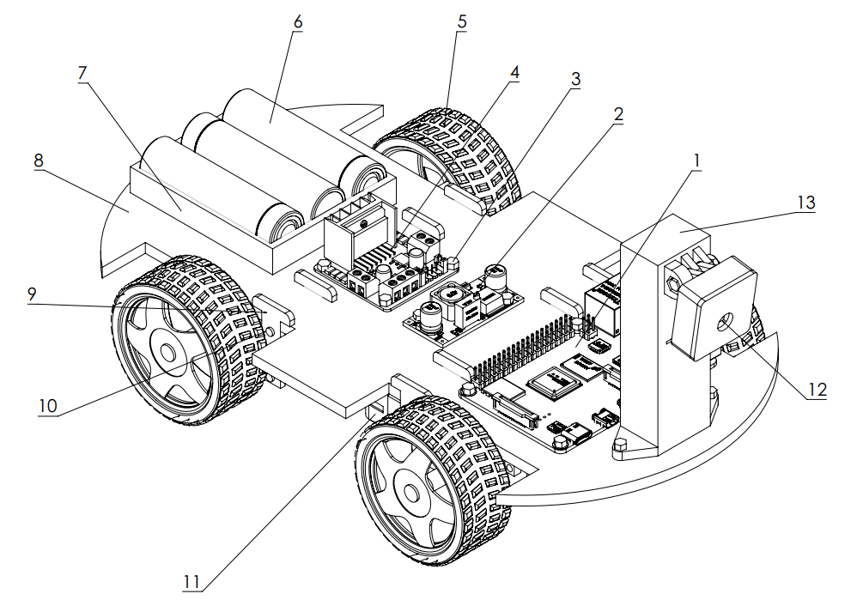

Figure .. The physical design of autonomous car model

Table 3.1. Components table of the autonomous car model

|  |  |  |  |
| --- | --- | --- | --- |
| Number | Part | Quantity | Material |
| 1 | Single-board Computer | 1 |  |
| 2 | Voltage Regulator | 1 |  |
| 3 | M4 Bolt and Screw | 10 | Steel |
| 4 | Motor Controller | 1 |  |
| 5 | Wheel | 4 |  |
| 6 | Battery Case | 3 |  |
| 7 | Battery | 1 |  |
| 8 | Chassis | 1 | Acrylic Plastic |
| 9 | Jigs | 8 | Acrylic Plastic |
| 10 | M3 Bolt and Screw | 8 | Steel |
| 11 | Electric Motor | 4 |  |
| 12 | Camera | 1 |  |
| 13 | Camera Case Assembly | 1 |  |

The car model’s parts arrangement is described as belows:

1. Camera is located in the front of the car. Because the camera is put on high position, this ensures the camera to capture wide-angle images.
2. Because the computer is the center point of all electric components so it is put in the middle of them for easier and more convenient wiring.
3. Motor controller is placed in the center of all four motors for more convenient wiring.
4. Batteries and voltage regulator is arranged so as to fit the remaining space on the chassis.

### Chassis

Chassis is the frame of the vehicle, the underpart of a motor vehicle, on which the body is mounted. Because there are many relatively large components are mounted on the chassis, I design the chassis so that it has the length of and width of. The design should also facilite the mesh of four motors to the chassis and have holes so that components can be attached by bolts or screws. Figure 3.2 is the picture of our chassis.

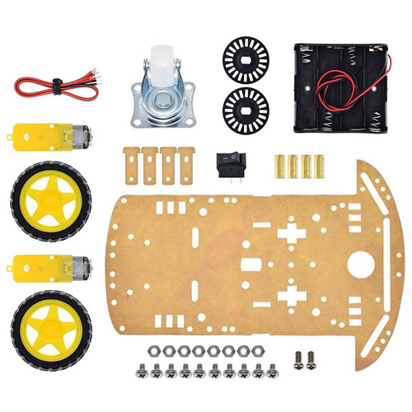

Figure .. Chassis

This compartment is large enough to contains huge items such as motor controller, microprocessor, two batteries, … and it also has the advantage of rearranging the components if needed. Choosing the material for the chassis is an important task that we have to be really careful when doing it. Because we will mount a lot of electronic components on it, the chassis must be electric insulation to ensure that electrons cannot flow through the chassis but flow correctly in the circuit as expected. And because the components that the chassis will carry are relatively heavy so chassis’ material should be solid, lightweight and strong. It also has to be cheap because the budget for this model is low. Based on these criteria, the most suitable material that I have found is acrylic plastic. Figure 3.3 shows some acrylic plastic plates. It is electric insulated, lightweight, strong and cheap. This type of material is widely available in the market, so it is very

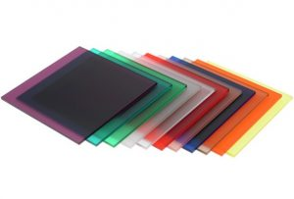

Figure .. Acrylic material

convenient when it needs to be replaced or repair some part of the robot. When using this material to build robots, we found that it creates rigidity for the base robot when subjected to a load from above.

### Camera case

The camera needs to be stable when the autonomous robot runs on the road so I design a camera case for solidifying the position of the camera on the chassis. The camera and its circuitry is protected by the camera case which has a hole in the middle 1 face so that light can reach the camera lens. The camera case design drawings are shown in figure 3.4.

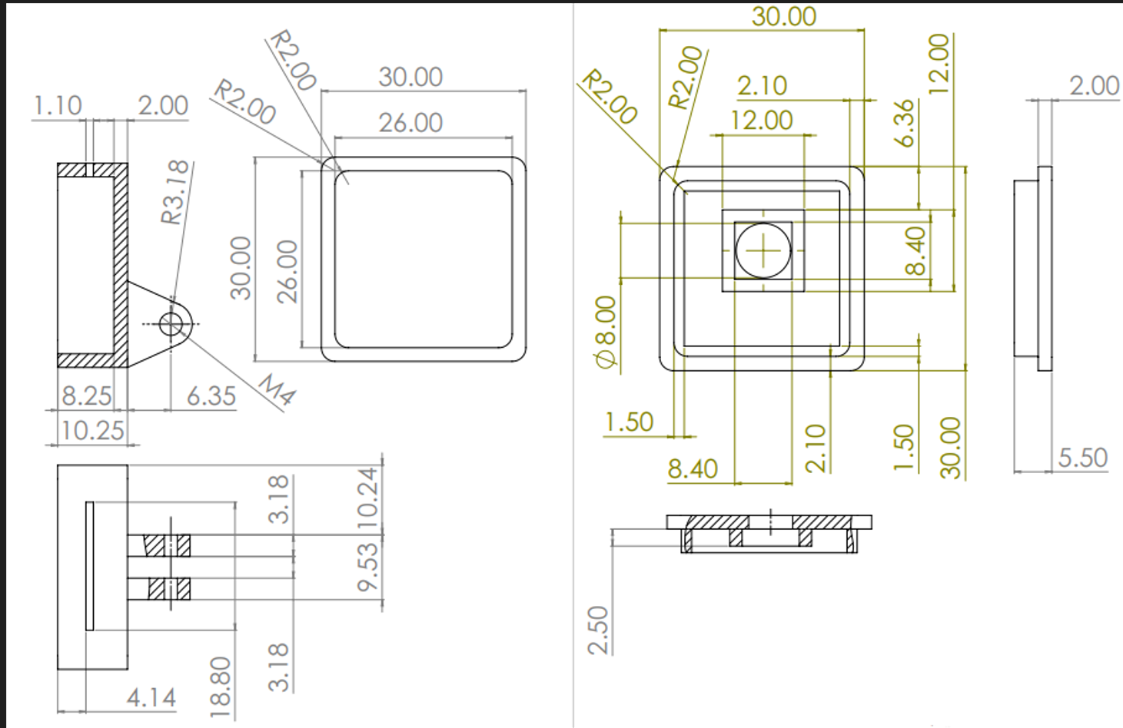

Figure .. Camera case design drawings

Because my camera needs to be high on the ground so as to take wide image frames, I design a camera pillar that has design drawing shown in figure 3.5. For the sake of flexibility, the camera case and pillar are connected by a hinge so that the camera is able to receive image frames from different angle. The camera case and pillar when assembled have the height and width as in figure 3.6. Table 3.2 shows the components listed in the drawings.

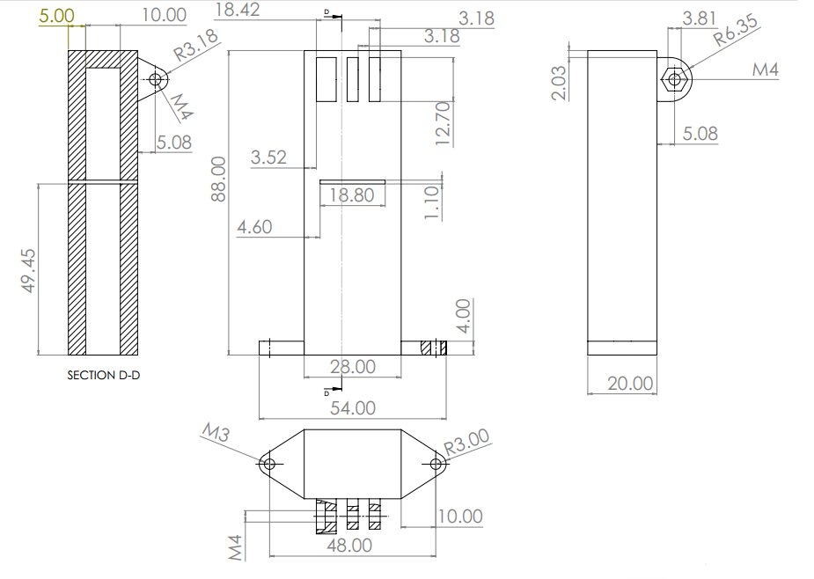

Figure .. Camera case pillar design drawing

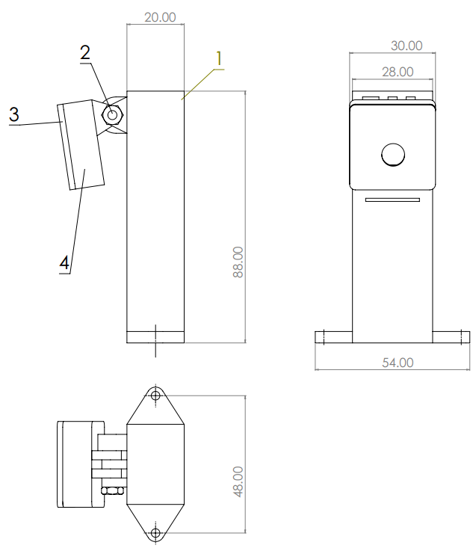

Figure .. Camera case and pillar assembly

Table 3.2. Components table of the camera case assembly

|  |  |  |  |
| --- | --- | --- | --- |
| Number | Part | Quantity | Material |
| 1 | Camera Case Pillar | 1 | ABS Plastic |
| 2 | M4 Screw and Bolt | 1 | Steel |
| 3 | Camera Case | 1 | ABS Plastic |
| 4 | Camera Shield | 1 | ABS Plastic |

To create physical parts that can be used and attached onto the autonomous car model, I use these design drawings and 3D print the parts. Figure 3.7 shows the 3D printed camera case.

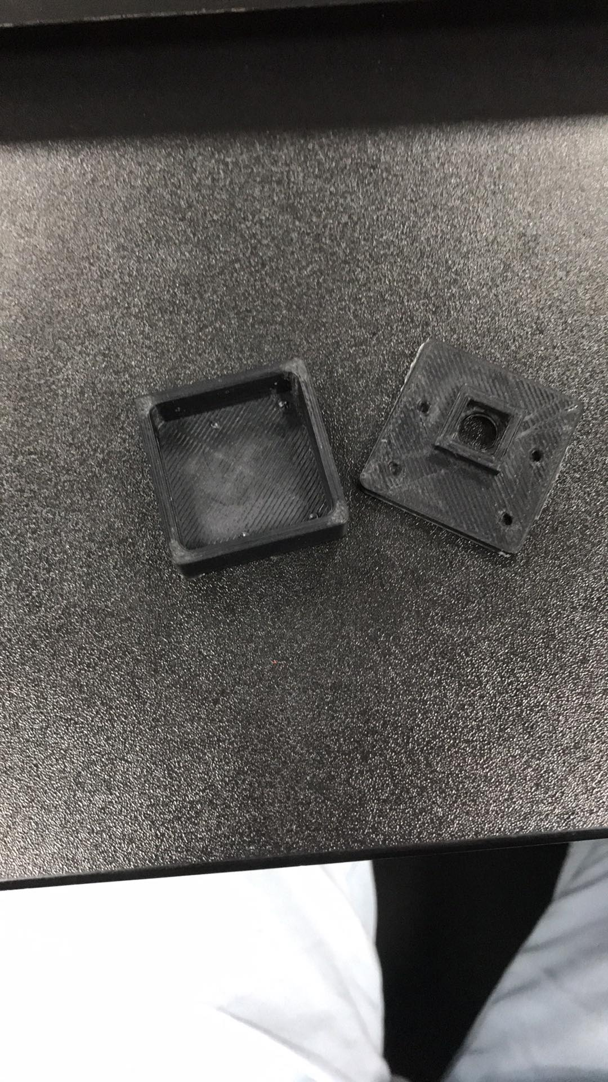

Figure .. 3D printing the camera case

The advantage of having a camera case like this is we can change angle of camera. Camera angle flexibility facilitates the process of matching the camera angle with the algorithm and minimizing the works for image warping process.

## Model Electrical Design

### Model schematic

In terms of wiring electric components, the camera’s 15 IO pins is connected with the computer through the connector located on the computer. The connector pins configuration is pre-defined by the Raspberry Pi manufacturer so we do not have to worry about its reliability. Next, we have 4 output pins of the computer connected with 4 input pins of the motor controller, these pins deliver the signal from the computer to the motor controller. Enable pins on the motor controller are connected with 5V as we always want the motor to run. Battery is wired directly with the motor controller and indirectly with the computer through the voltage regulator. All the electric components must have the same common ground by wiring their ground pins with the negetive wire of the battery. The figure 3.8 shows the car model schematic.

### Raspberry Pi 4 Model B

Raspberry Pi is a series of small single-board computers developed in the United Kingdom by the Raspberry Pi Foundation in association with Broadcom. In our

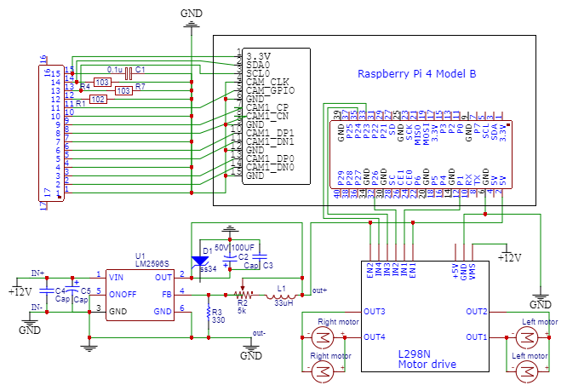

Figure .. Model schematic

model, this single-board computer is responsible for processing images captured by the camera and send signals to motor controller. Figure 3.9 shows some components of the Raspberry Pi 4.

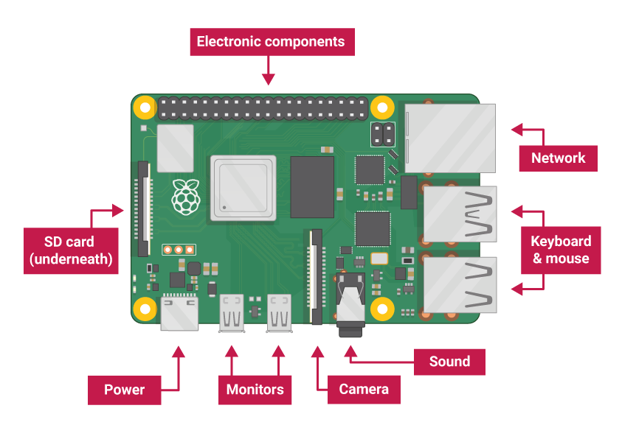

Figure .. Raspberry Pi 4

Raspberry Pi 4 Model B has the latest high-performance Quad-Core 64-bit Broadcom 2711, Cortex A72 processor clocked at 1.5GHz speed. It has dual-display support up to 4k resolutions via a pair of micro-HDMI ports, hardware video decodes at up to 4Kp60, dual-channel 2.4/5.0GHz wireless LAN, true Gigabit Ethernet, two USB 3.0 ports, Bluetooth 5.0, and PoE capability which are more than enough to run our autonomous robot.

#### Power supply

Raspberry Pi 4 Model B needs a power supply of 5.1V-3A for normal operation. In this model, I have already had 3 batteries which output voltage is 12V. For safe operation of the microcontroller, I use a voltage regulator to convert 12V to 5V.

#### Operating system

In this study, I will use the most famous operating system for Raspberry Pi which is Raspberry Pi OS. It is a Debian-based operating system and has been officially provided by the Raspberry Pi Foundation as the primary operating system for the Raspberry Pi family of compact single-board computers.

#### Memory unit

Raspberry Pi needs an external memory unit to store the operating system. The memory unit effects how fast information is loaded in the CPU for processing and how much information the computer can stored. There for, there are two criteria to choose an external storage for Raspberry Pi which are storage space and its quality. Here, I use a 64GB SD card of SanDisk, which can be seen in figure 3.10.



Figure .. The SD Card

#### GPIO pinout

Raspberry Pi GPIO stands for General Purpose Input Output pins. These pins are used to connect the Raspberry pi board to external input/output peripheral devices. This model B consists of a 40-pin GPIO header. Out of these 40 pins, 26 pins are GPIO pins. Since GPIO pins do not have any specific function, these pins can be customized using the software. It consists of two 5V pins, two 3V3 pins, and 7 ground pins (0V). The 5V: The 5v pin outputs the 5 volts coming from the USB Type-C port. 3.3V: The 3v pin is used to provide a stable 3.3v supply to external components. GND: The ground pin is commonly referred to as GND. A GPIO pin set as input allows the signal transmitted by any external device (connected to this pin) to be received by the Raspberry Pi. Input voltage between 1.8V and 3.3V is read as HIGH by the Raspberry pi. And when the input voltage is lower than 1.8V, it is read as LOW. Figure 3.11 shows the output pins of Raspberry Pi 4.

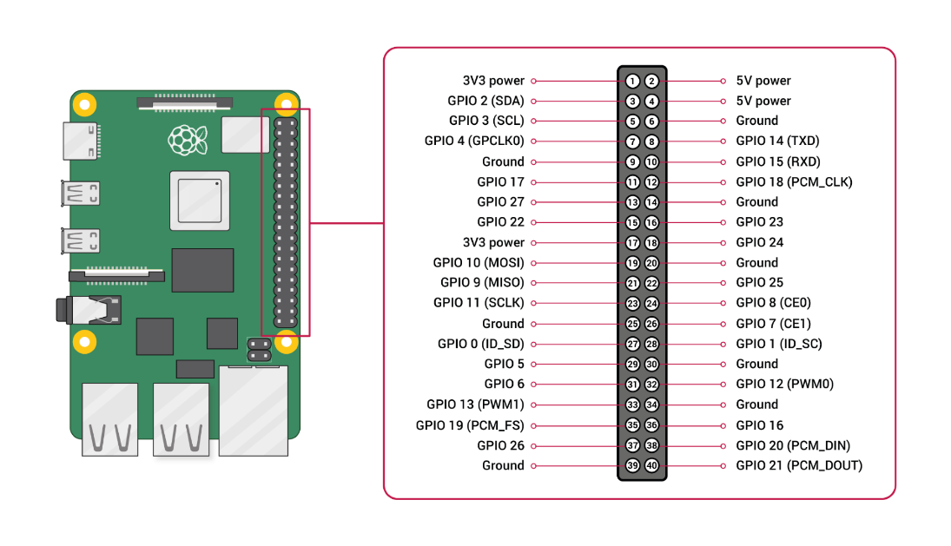

Figure .. Raspberry Pi 4 Model B GPIO pins

We will use Raspberry Pi 4’s 4 output pulse width modulation (PWM) pins. It means that an analog value is being modulated on a digital signal so PWM pins can be used to control the speed of the motors, other pins cannot be used to do this because it can only output digital 0’s and 1’s signal (either fully stop or maximum speed). The output PWM pins are GPIO12, GPIO13, GPIO18, GPIO19. For communication with other microcontrollers, processors, electronic devices, we can use SPI, I2C or UART pins. SPI (Serial Peripheral Interface) is a type of serial communication protocol. It is used by the Raspberry Pi for master-slave communication to quickly communicate between one or more peripheral devices. The data is synchronized using a clock (SCLK at GPIO11) from the master (RPi). The Pi sends this data to an SPI device using MOSI (Master Out Slave In) pin. And when the SPI device needs to communicate back to the Raspberry Pi, it sends the data back through the MISO (Master In Slave Out) pin. 5 pins are required for SPI communication:

1. GND: Connect the GND pin from all the slave components and the Raspberry Pi 4 board together.
2. SCLK: Clock for SPI communication.
3. MOSI: It stands for Master Out Slave In. This pin is used to send data from the master to a slave.
4. MISO: It stands for Master In Slave Out. This pin is used to receive data from a slave to the master.
5. CE: It stands for Chip Enable. We need to connect one CE pin per slave (or peripheral devices) in our circuit. By default, we have two CE pins but we can configure more CE pins from the other available GPIO pins.

I2C pins on the Raspberry Pi board are used to communicate with peripheral devices that are compatible with Inter-Integrated Circuit (a low-speed two-wire serial communication protocol). This serial communication protocol requires master-slave roles between both, the board and the peripheral devices. I2C protocol requires two connections: SDA (Serial Data) and SCL (Serial Clock). They work by transmitting data using the SDA connection, and the speed of data transfer is controlled via the SCLK pin. The UART (Universal Asynchronous Receiver / Transmitter) is an asynchronous protocol that provides a way to communicate between two microcontrollers or devices. TX pin transmits the serial data to the RX pin of another device and RX pin receives the serial data coming from TX pin of the other device. The physical dimension of the Raspberry Pi 4 is 85 mm in length and 56 mm in width as shown in the figure 3.12.

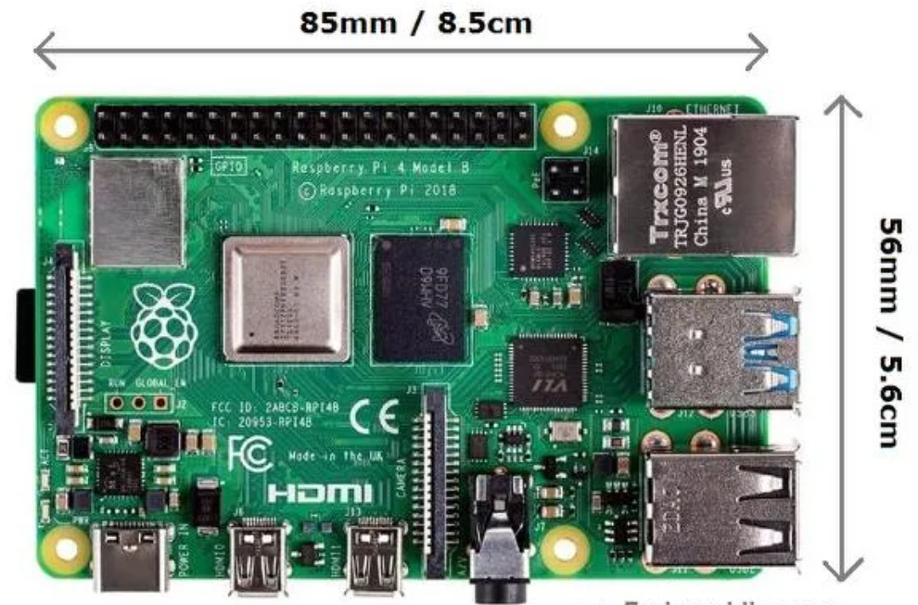

Figure .. Raspbery Pi 4 Model B physical dimensions

### Electric motor

About the propulsion of the autonomous vehile, I use four electric motors to drive the vehicle. They are directly controller by the motor controller. This motor is widely used for robot design, DIY model, ... Their operating range are from 3V to 12V, 250-1000mA. When operating in 3V, it is 125 revolutions per minute and when operating 5V, it is 208 revolutions per minute. Its physical dimension is 64x19x22.6mm with weight of 27g as shown in the figure 3.13.

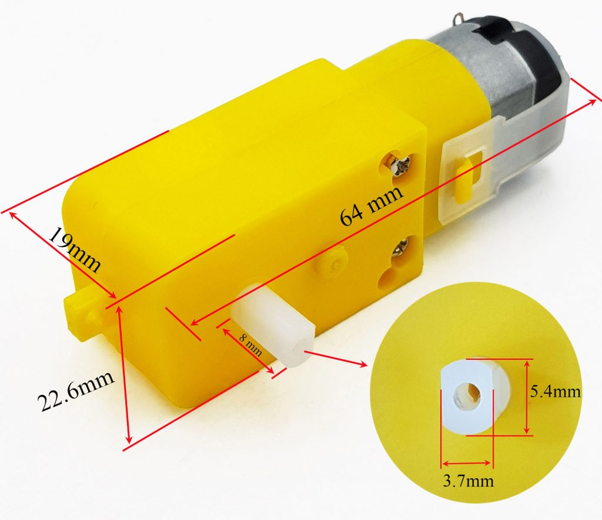

Figure .. Electric motor used in the autonomous robot

### Motor controller

This part is used to control the motors according to signal from the computer. Because the signal from the computer does not have enough power to run the motors, we need a motor controller to receive signal and output a sufficient power to control the motors. To have complete control over DC motor we have to control its speed and rotation direction. This can be achieved by combining these two techniques: PWM – to control speed and H-Bridge – to control the rotation direction. Figure 3.14 shows the motor controller used in the project.

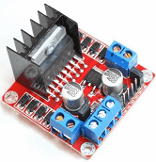

Figure .. Motor controller

The speed of a DC (direct current) motor can be controlled by changing its input voltage. A common technique to do this is to use PWM (pulse width modulation). PWM is a technique where the average value of the input voltage is adjusted by sending a series of ON-OFF pulses. The average voltage is proportional to the width of the pulses known as the Duty Cycle. The higher the duty cycle, the higher the average voltage applied to the DC motor (resulting in higher speed) and the shorter the duty cycle, the lower the average voltage applied to the DC motor (resulting in lower speed). Figure 3.15 shows PWM technology with different duty cycles and average voltages.

The spinning direction of a DC motor can be controlled by changing the polarity of its input voltage. A common technique for doing this is to use an H-bridge. An H-bridge circuit consists of four switches with the motor in the center forming an H-like arrangement. Closing two specific switches at a time reverses the polarity of the voltage applied to the motor. This causes a change in the spinning direction of the motor. The figure 3.16 and 3.17 show the working of the H-bridge circuit.

At the center of the module is chip with a heat sink – the L298N as can be seen in figure 3.18. Inside the L298N chip, you’ll find two standard H-bridges capable of driving a pair of DC motors. This means it can drive up to two motors individually which makes it ideal for building a two-wheeled robotic platform. The L298N motor driver has a supply range of 5V to 35V and is capable of 2A continuous current per channel, so it works very well with most of our DC motors. Schematic of the motor controller and the motors is drawn in figure 3.19.

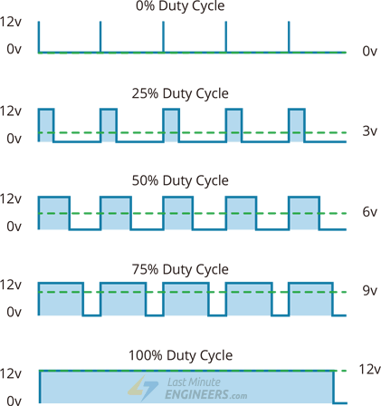

Figure .. Pulse Width Modulation with different duty cycles

|  |  |
| --- | --- |
| Figure .. H-Bridge counter-clockwise motor rotation | Figure .. H-Bridge clockwise motor rotation |

The L298N motor driver has two input power pins – VS and VSS. VS pin gives power to the internal H-Bridge of the IC to drive the motors. We can connect an input voltage anywhere between 5 to 12V to this pin. VSS is used to drive the logic circuitry inside the L298N IC which can be 5 to 7V. GND is the common ground pin. The L298N motor driver’s output channels OUT1 and OUT2 for motor A and OUT3 and OUT4 for motor B are broken out to the edge of the module with two 3.5mm-pitch screw terminals. Each channel of the module can deliver up to 2A to the DC motor. However, the amount of current supplied to

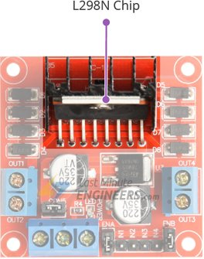

Figure .. L298N Chip

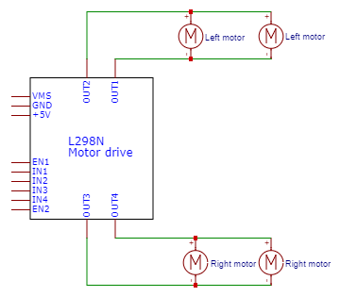

Figure .. Motor controller schematic

the motor depends on the power supply of the system. By using the direction control pins, you can control whether the motor rotates forward or backward. These pins actually control the switches of the H-Bridge circuit inside the L298N chip. The module has two direction control pins for each channel. The IN1 and IN2 pins control the spinning direction of motor A; While IN3 and IN4 control the spinning direction of motor B. The spinning direction of the motor can be controlled by applying logic HIGH (5V) or logic LOW (Ground) to these inputs. Table 3.3 shows how this is done.

The speed control pins ENA and ENB are used to turn on/off the motors and control its speed. Pulling these pins HIGH will cause the motors to spin, while pulling it LOW will stop them. But, with Pulse Width Modulation (PWM), you

Table 3.3. Control the direction of the motor

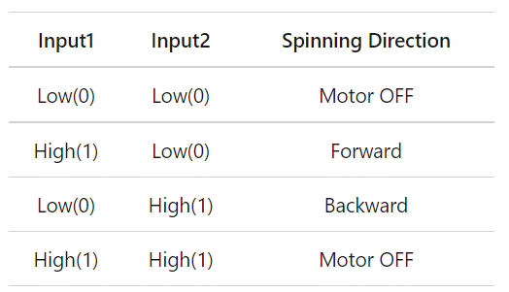

can actually control the speed of the motors. The module usually comes with a jumper on these pins. When this jumper is in place, the motor spins at maximum speed. If we want to control the speed of the motors programmatically, we need to remove the jumpers and connect them to the PWM-enabled pins on the Raspberry Pi 4.

### Battery

To have a stable power supply, I use a rechargable NCR18650 battery. The battery output voltage is from 3.7V to 4.1V, but the operating range of motors are 3V to 12V so I use three of this battery connected in series. Its output current can be up to 30A which is more than enough to supply the power for both motor controller and the computer.

### LM2596 voltage regulator

Because the input voltage of the Raspberry Pi 4 is 5V – 3A, we have to have a voltage regulator to convert the 12V to 5V for safe operation of the microprocessor. Also, the output voltage of the voltage regulator should be 3A. One of the module that is suitable is LM2596 which has schematic shown in figure 3.20.

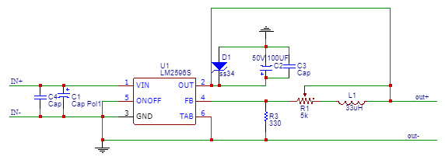

Figure .. LM2596 voltage regulator

The LM2596 voltage regular uses LM2596S that has 6 pins to interact with the world:

1. VIN: Input voltage that we want to convert
2. OUT: Output voltage
3. GND: Common ground pin
4. FB: Feedback pin
5. ONOFF: Pull this pin low then it is turned on
6. TAB: Another ground pin.

As can be seen in the schematic in the figure 3.15, the “output+” voltage can be manipulated by changing the value of the rheostat R1. Our desired output voltage value is 5V so we connect the output positive and negative wire with a multimeter and try to increase/decrease the value of the rheostat until getting 5V on the display of the multimeter.

### Camera and camera case

Camera is a sensor used to capture image frames and send them to the microcontroller through its circuitry. It must be compatible with Raspberry Pi 4 so I use Camera Pi, which is designed by the Rasberry Pi manufactorer. Camera Pi needs a 3.3V input voltage, it is supplied by the microprocessor itself. Data communication between the camera and Raspberry Pi is done by I2C protocol with 1 SDA which contains data (images) and SCL which produces clock for synchronization. Schematic of the camera is drawn in the figure 3.21.s

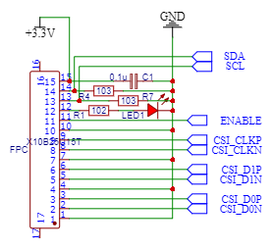

Figure .. Camera Pi schematic

## Running the Autonomous Car

### The problems when running the car model

These are some problems when actually running on the path. It did not do well because of several problems:

Problems related to physical and electrical design:

1. Camera position is not suitable with the algorithm. This makes the car can not correctly detect the lane.
2. The power supply is not enough to power electric components.
3. The output power is lower/higher than algorithm’s expected value. These values should be equal so that the speed of the motors correctly represents intent of the algorithm.

Problems with the algorithm:

1. The car model is too sensitive with just a slight change of the lane curve.
2. Algorithm is not optimized so that the time it takes to convert input image to output curve take so much time. Real-time problem needs real-time solution. The algorithm needs to process input images much faster.

### Solutions

The solutions for physical and electrical design of the autonomous car is straightforward: trying different camera angles until the car runs correclty and use more stable and rechargable batteries. To solve the problems related to the algorithm, several things have been made in an attempt to help it decoding the image faster and more precise:

1. Try different curve sensitivity until the car model runs correctly when detected lane curve.
2. Use a more optimized programming language: keep the algorithm the same but convert all the Python code to C++ code. Python is a user-friendly programming language, but it is a tradeoff for the program speed.
3. Pro-process the input images: input images are color images. A color image is three times larger in size in comparison with a grey scale image. The larger the input, the more the algorithm works and the longer time it needs to decodes the input. Because our problem only concerns the lightness of the image so we can convert input color image to gray scale ones. Another way that I have added to the algorithm to reduce the size of input images is cropping out the uninterested area in these images.

Figure 3.22 shows the final result when the car correctly runs on the path.

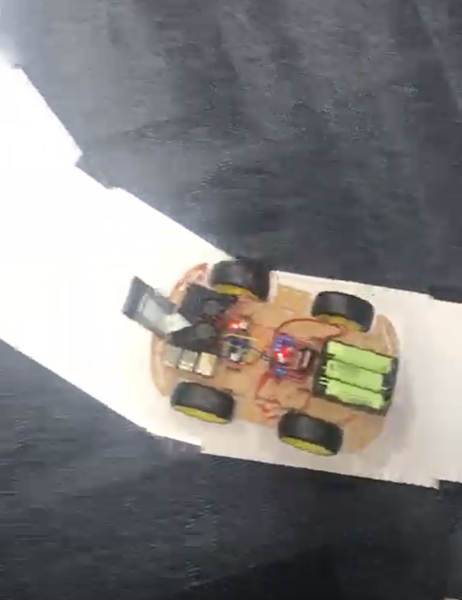

Figure .. The autonomous car when running correctly

# CONCLUSION

## Conclusion

Because this project requires expertise of different fields, I gained a lot of knowledge that is interesting and useful for my future works. Some of the topics that I have learnt are: embedded programming, artificial intelligent, how to design physical robot model, how to write Python code. The things I have done in this project are:

1. Exploring various computer vision ideas and its applications.
2. Designing and 3-dimension printing most physical parts of the autonomous car model.
3. Choosing appropriate electronics devices for the model.
4. Assembling the car model and applying computer vision to teach the microprocessor how to detects the driving lane and control robot’s motors accordingly.
5. The car model runs correctly as expected and this reaches the objectives that I set at the beginning of the project.

## Future Work

It is a long way to go and a lot of ideas and experiments are still to come. And because this image processing algorithm has many incapabilities when put on different scenarios, possible extensions for the algorithm maybe:

1. Adding more sensors for measurement
2. Including deep learning models to recognize objects on the path
3. Applying simultaneous localization and mapping

And in term of the algorithm itself, a lot of further experiments could be done of which some may really improve the algorithm. It maybe adding another layer of image preprocessing to the algorithm such as image cropping to choose only the interested areas in the image or choosing automatic thresholding rather than choosing it manually. There are endless possibilities of how the algorithms might be improved and how they could be combined. It is important to keep up the work for future progress.

# REFERENCES

|  |  |
| --- | --- |
| [1] | C. L. Hansen, Digital image processing for clinicians, part I: Basics of image formation, Journal of Nuclear Cardiology, 2002. |
| [2] | F. J. D. Van Dam, Fundamentals of Interactive Computer Graphics, Reading, MA: Addison-Wesley, 1982. |
| [3] | D. Anderson, Color Spaces in Frame Grabbers: RGB vs. YUV, Archived from the original, 2008. |
| [4] | H. G. Völz, Industrial Color Testing: Fundamentals and Techniques, Wiley-VCH, 2001. |
| [5] | O. developers, "opencv.org," OpenCV, 2017. [Online]. Available: https://docs.opencv.org/3.4/d3/dc1/tutorial_basic_linear_transform.html. [Accessed 2022]. |
| [6] | J. N. Kapur and P. K. Sahoo, A new method for gray-level picture thresholding using the entropy of the histogram, Journal of Vision, 1985. |